**Deploying a multi-tier website using AWS EC2**

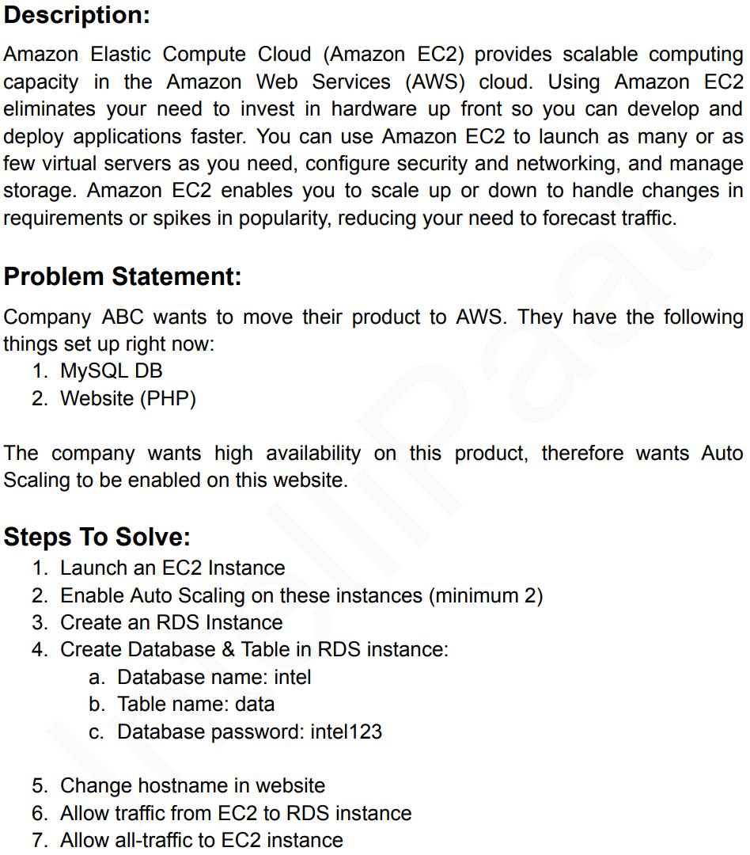

**GitHub link for the PHP code -** <https://github.com/MiksVeg/php-code.git>

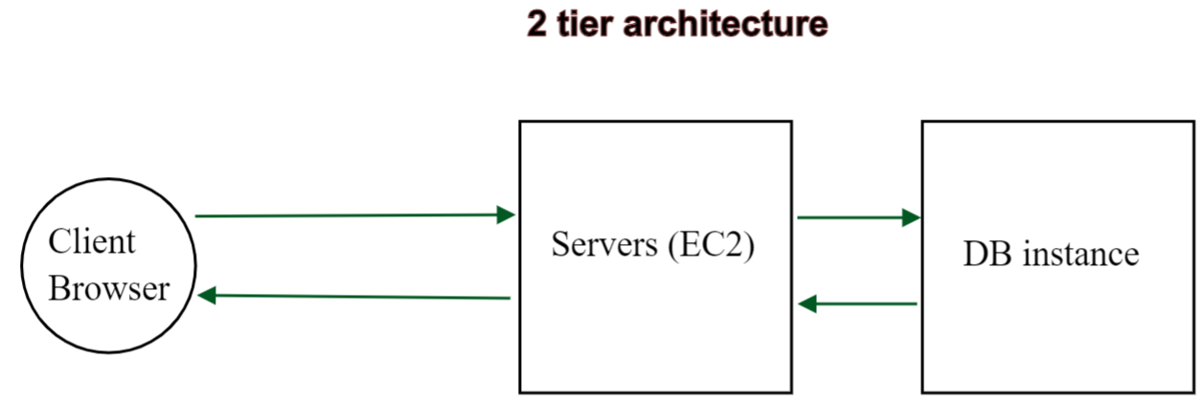

HTTP response

HTTP request

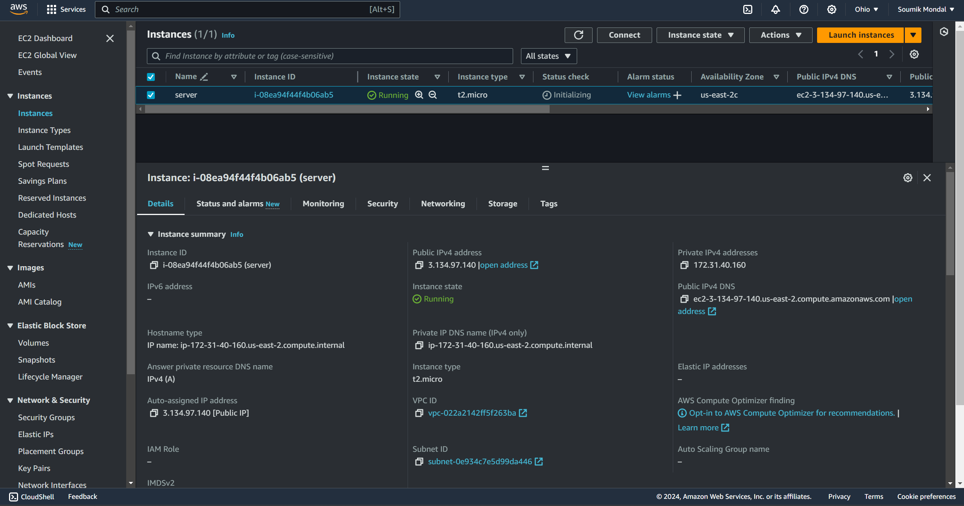  
**Deployed an ec2 instance**

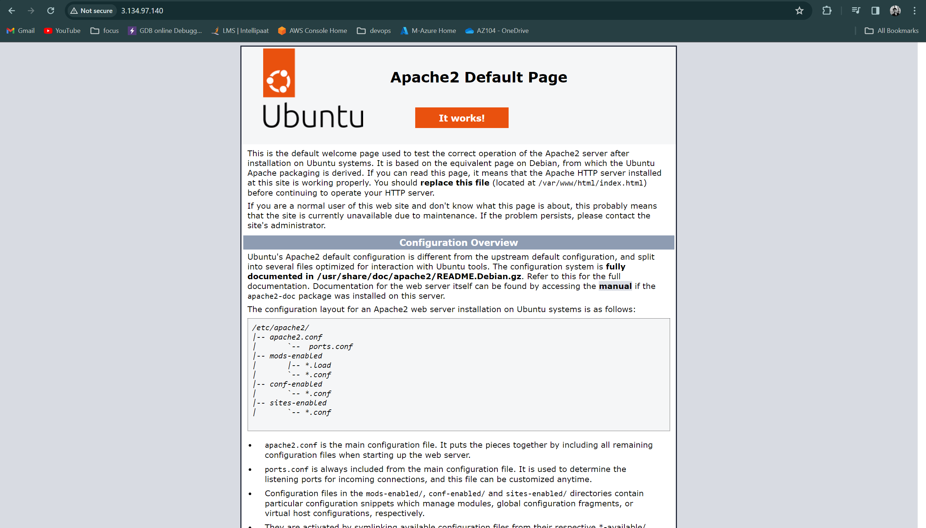  
**Updated the instance and installed apache2**

**Now we have to work on few steps inside the VM-**

* remove index.html file –
  + cd /var/www/html
  + sudo rm index.html
* clone a git repository for PHP code –
  + sudo git clone <https://github.com/MiksVeg/php-code.git>
  + sudo mv php-code/* .
  + sudo rm -r php-code

**Now let’s create an MySQL RDS (Relational database service)**

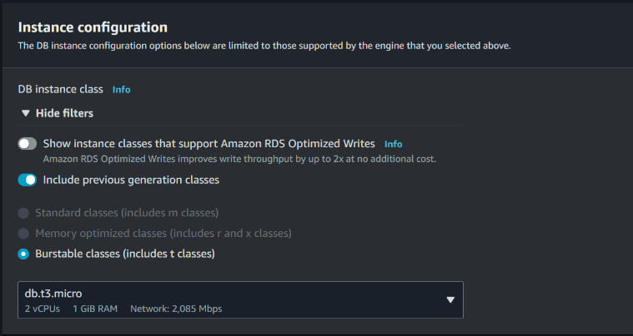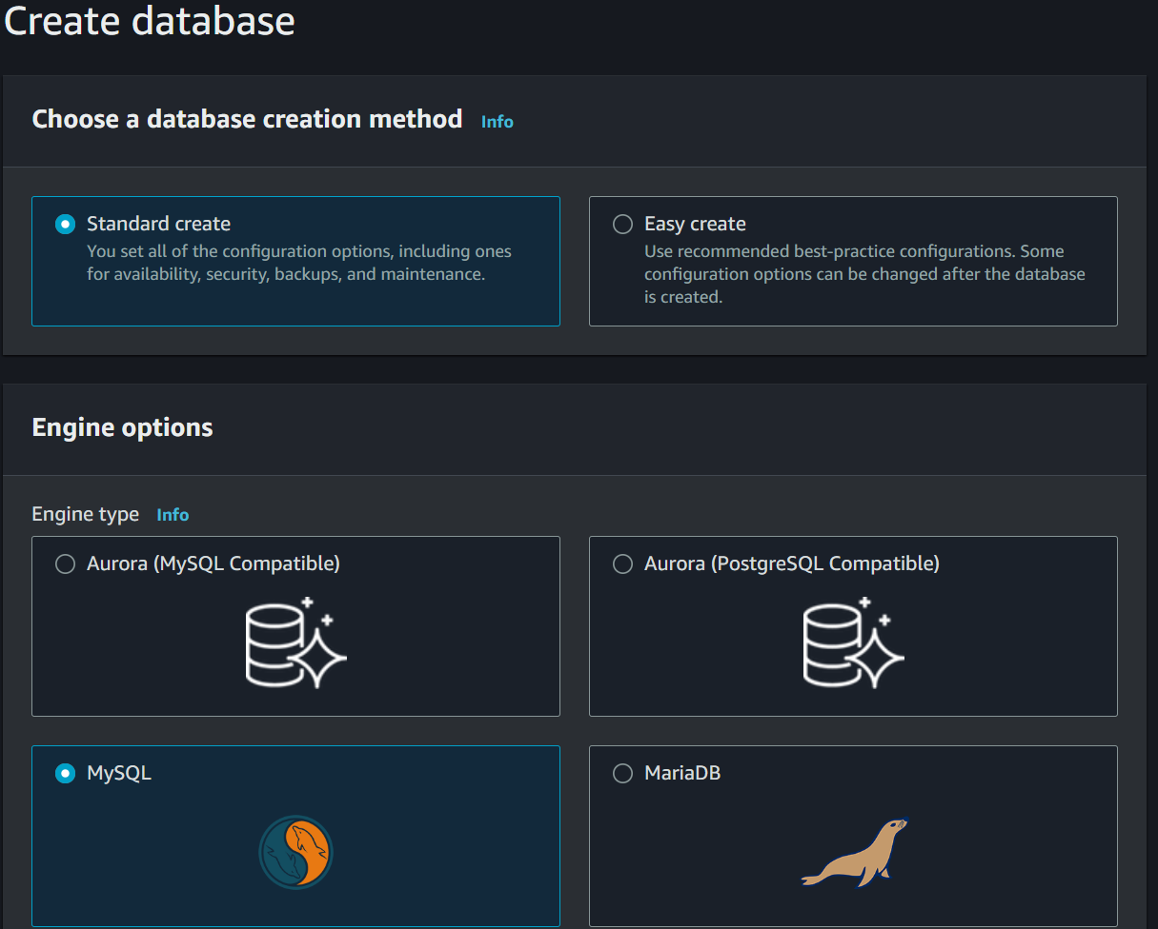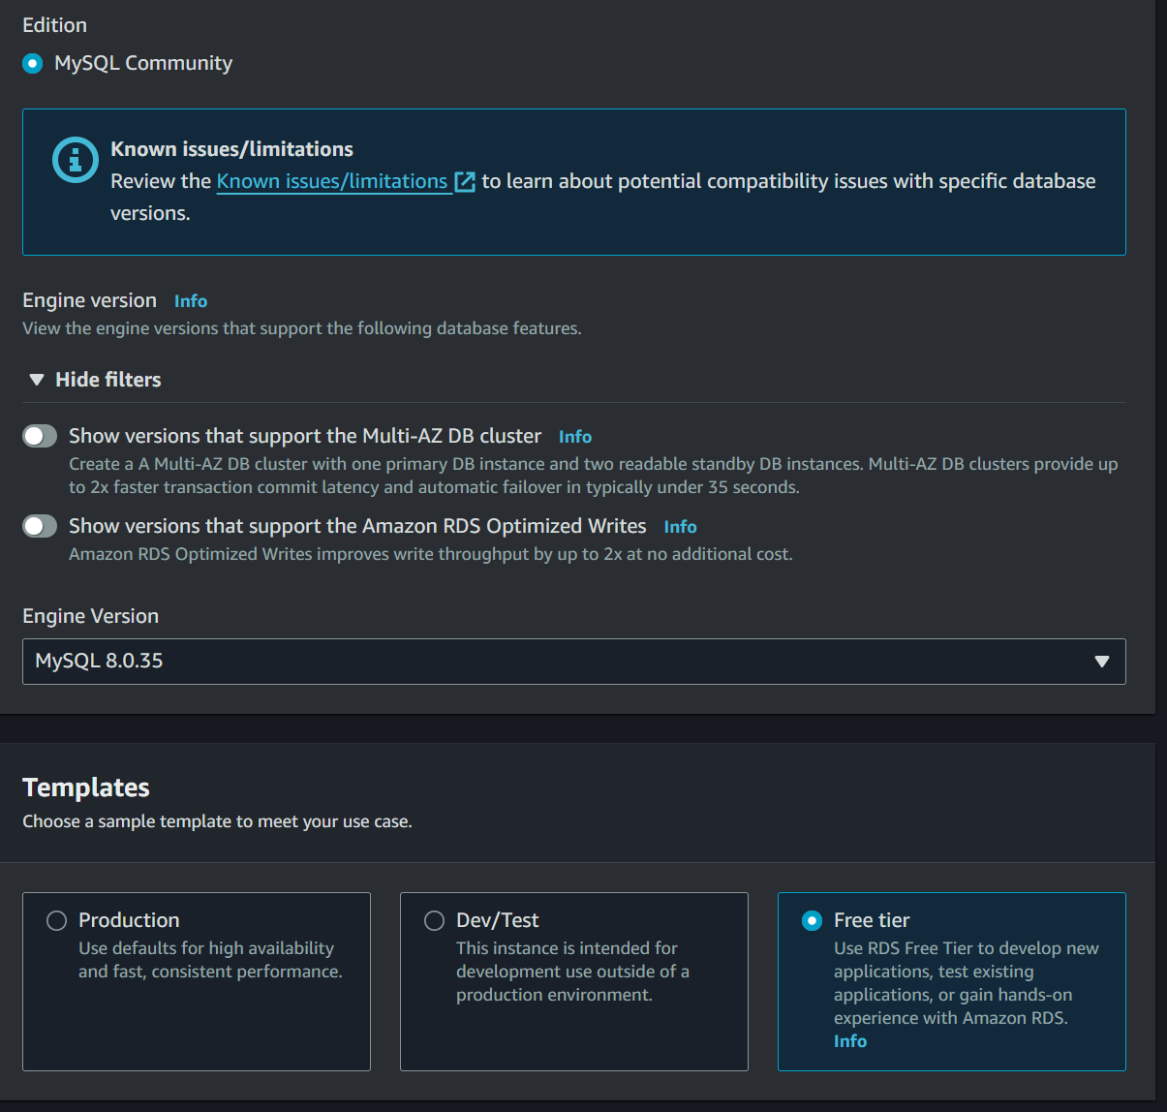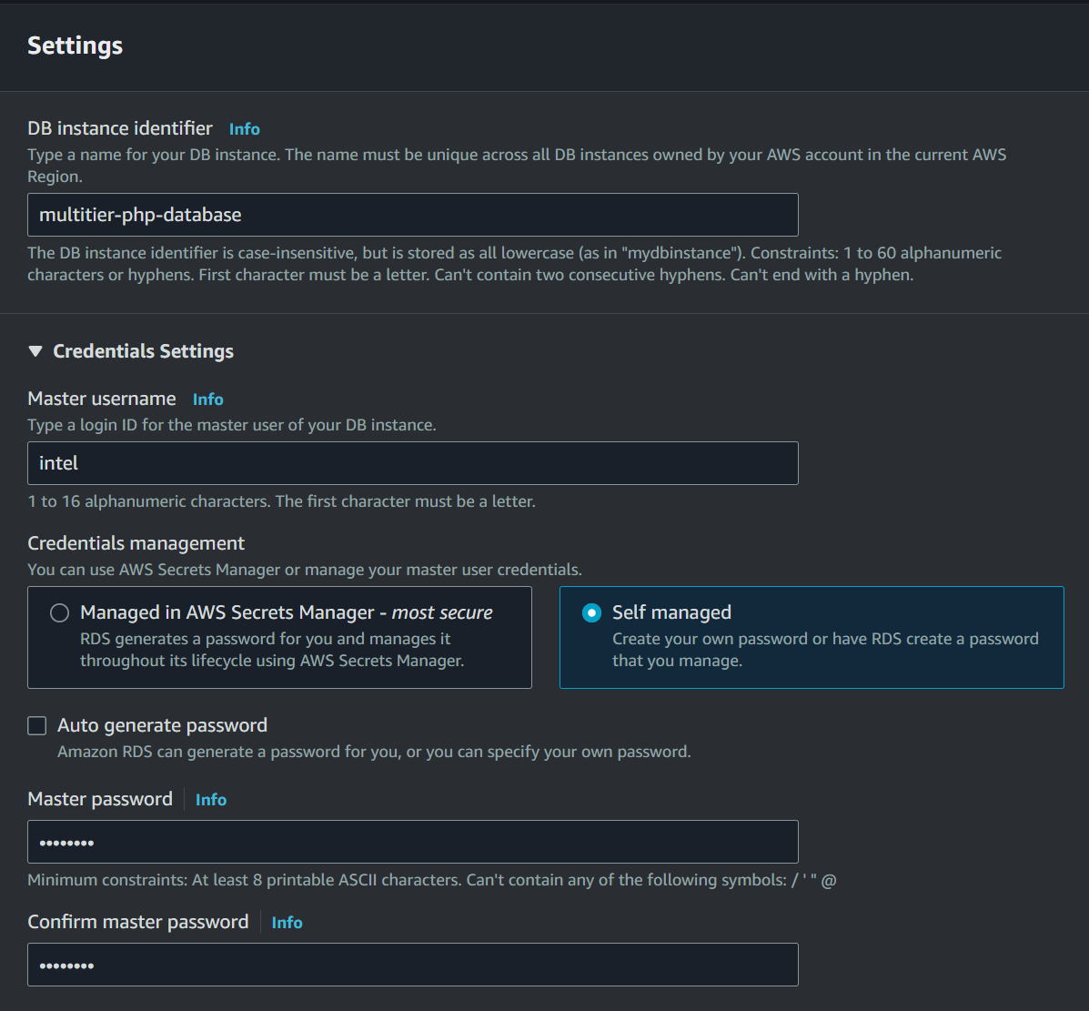



password should be intel123 as per the instruction

User name should be intel as per the instruction

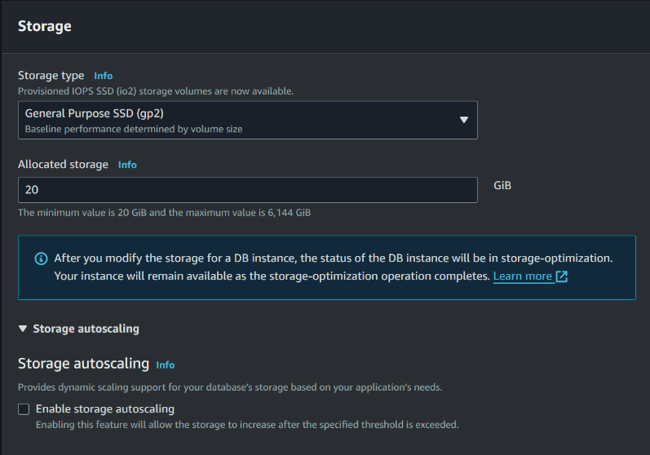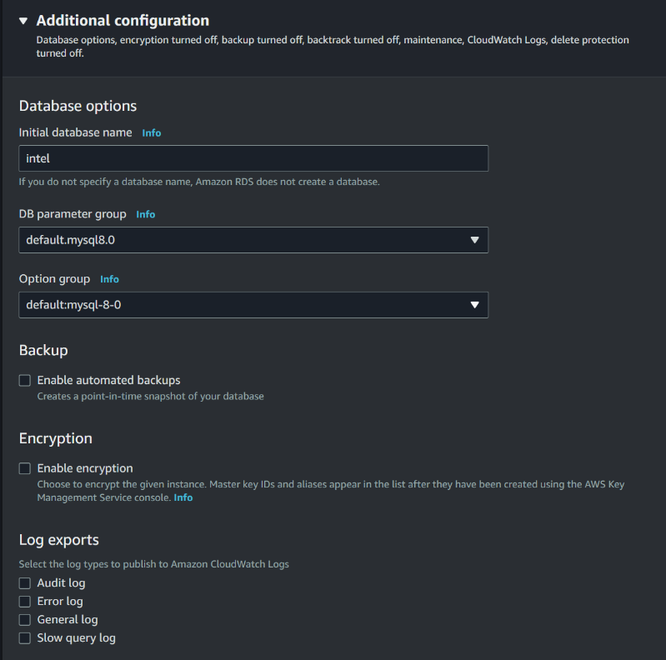

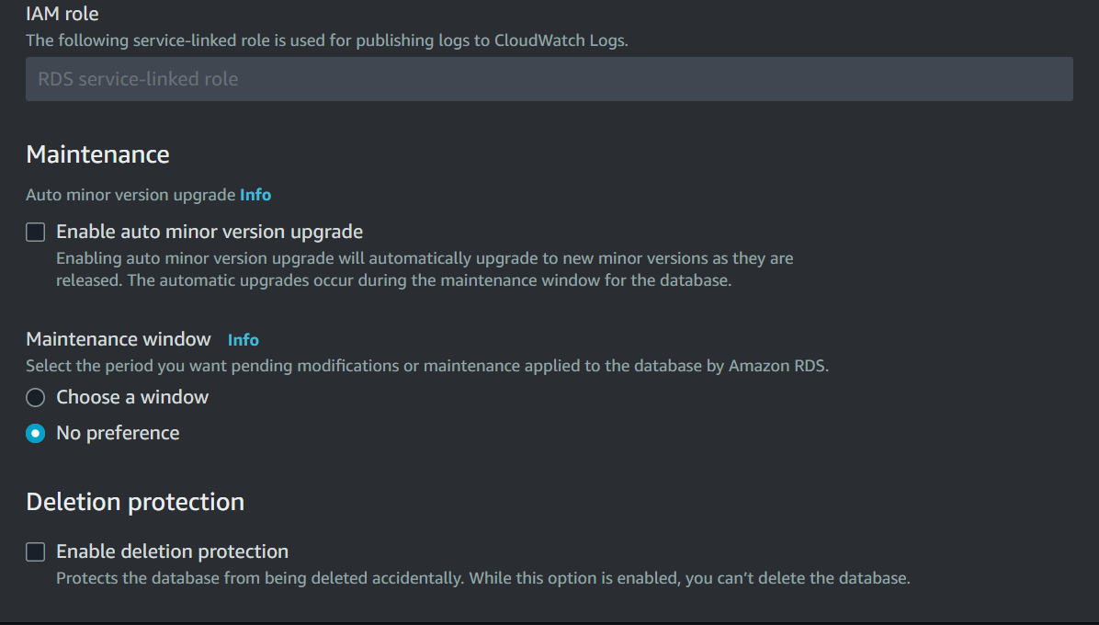



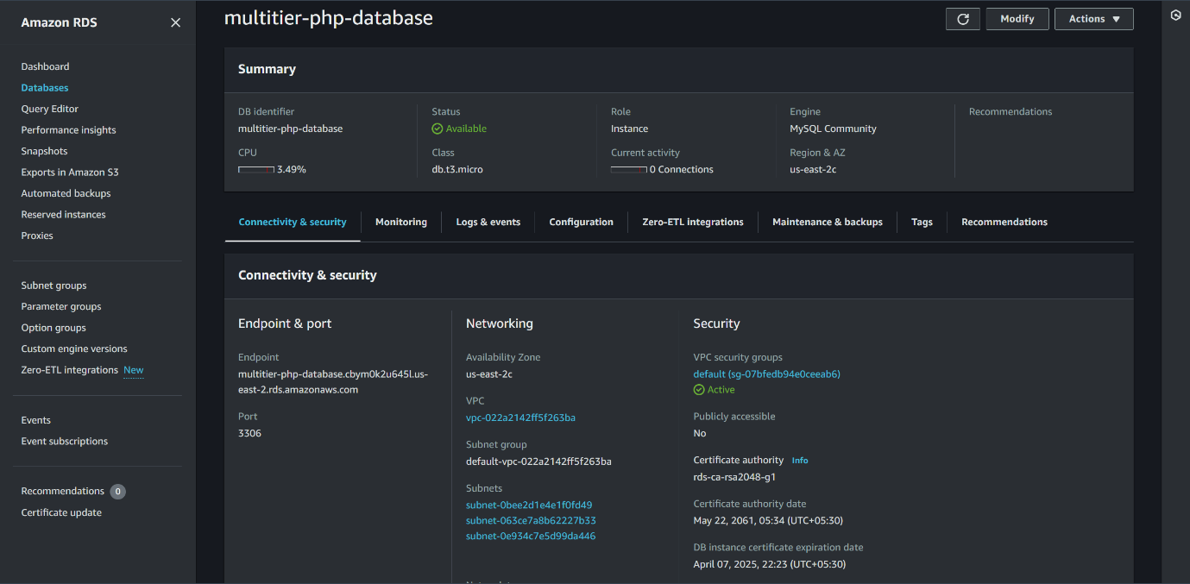

Copy this end point

**Successfully created RDS instance**

**Go inside the index.php file and replace the endpoint –** sudo nano index.php**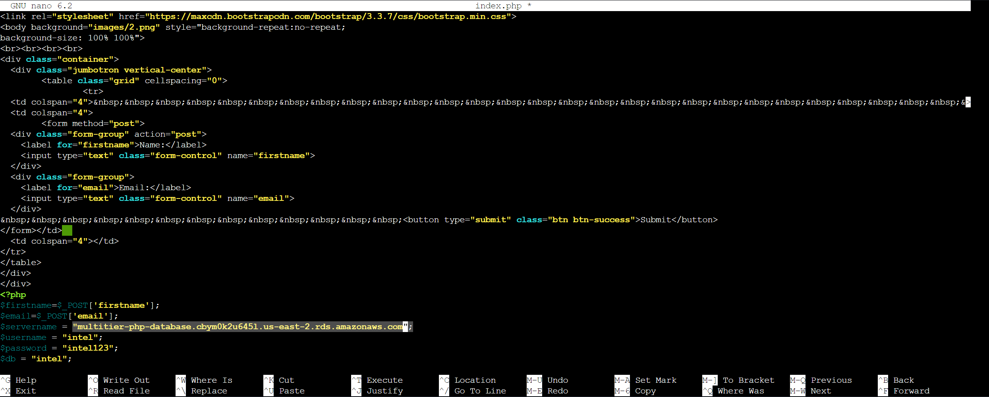Replaced the endpoint (servername)**

Paste the endpoint

**Now let’s install the MySQL server inside the VM -** sudo apt install mysql-server -y**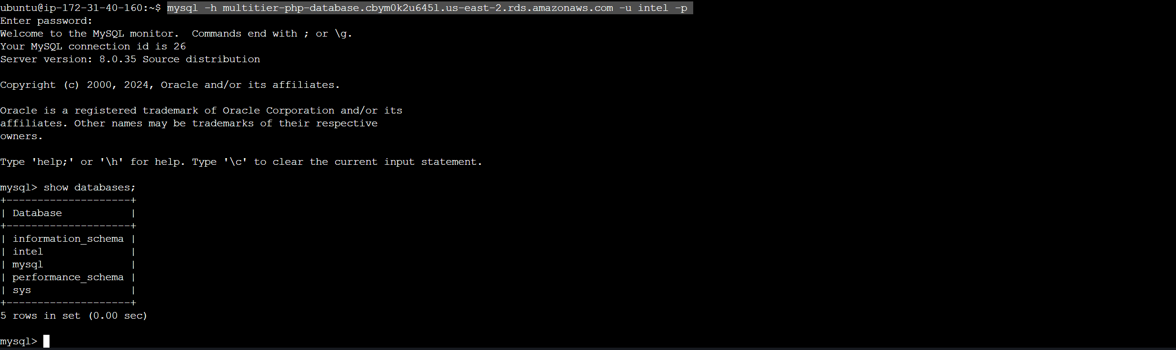  
Logged in to the MySQL server**

show databases – to show the databases inside the RDS

mysql -h <endpoint> -u intel -p



use intel

**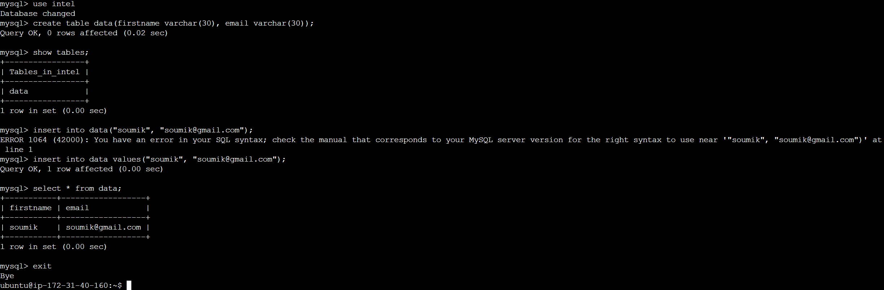  
Configuring the MySQL server with testing with some data insertion and retrieval**

select * from data;

**Paste the VM IP address in the browser**

**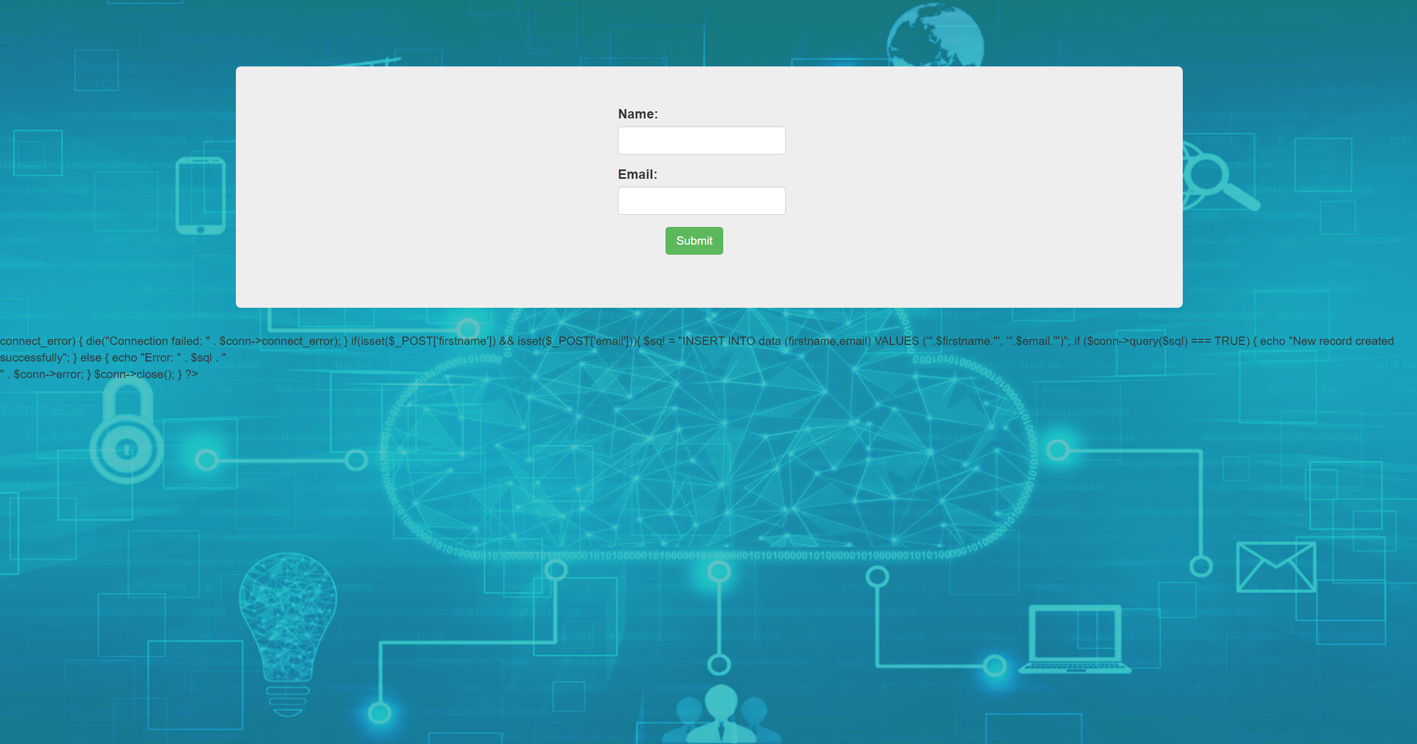  
We are having some error on the page.**

**Now we need to install some PHP packages into the VM-**

* **sudo add-apt-repository -y ppa:ondrej/php**
* **sudo apt install php5.6 mysql-client php5.6-mysqli**

**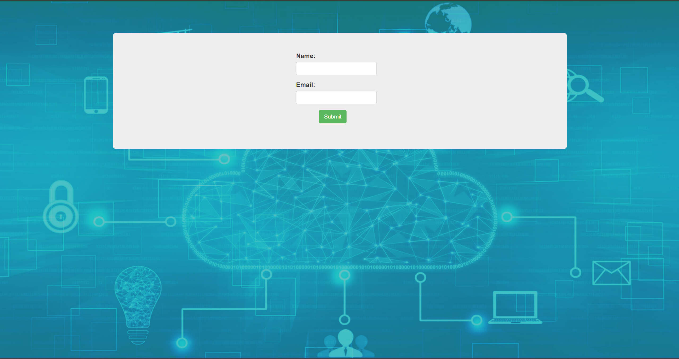  
All the errors are gone**

**Now Let’s test PHP web server-**

**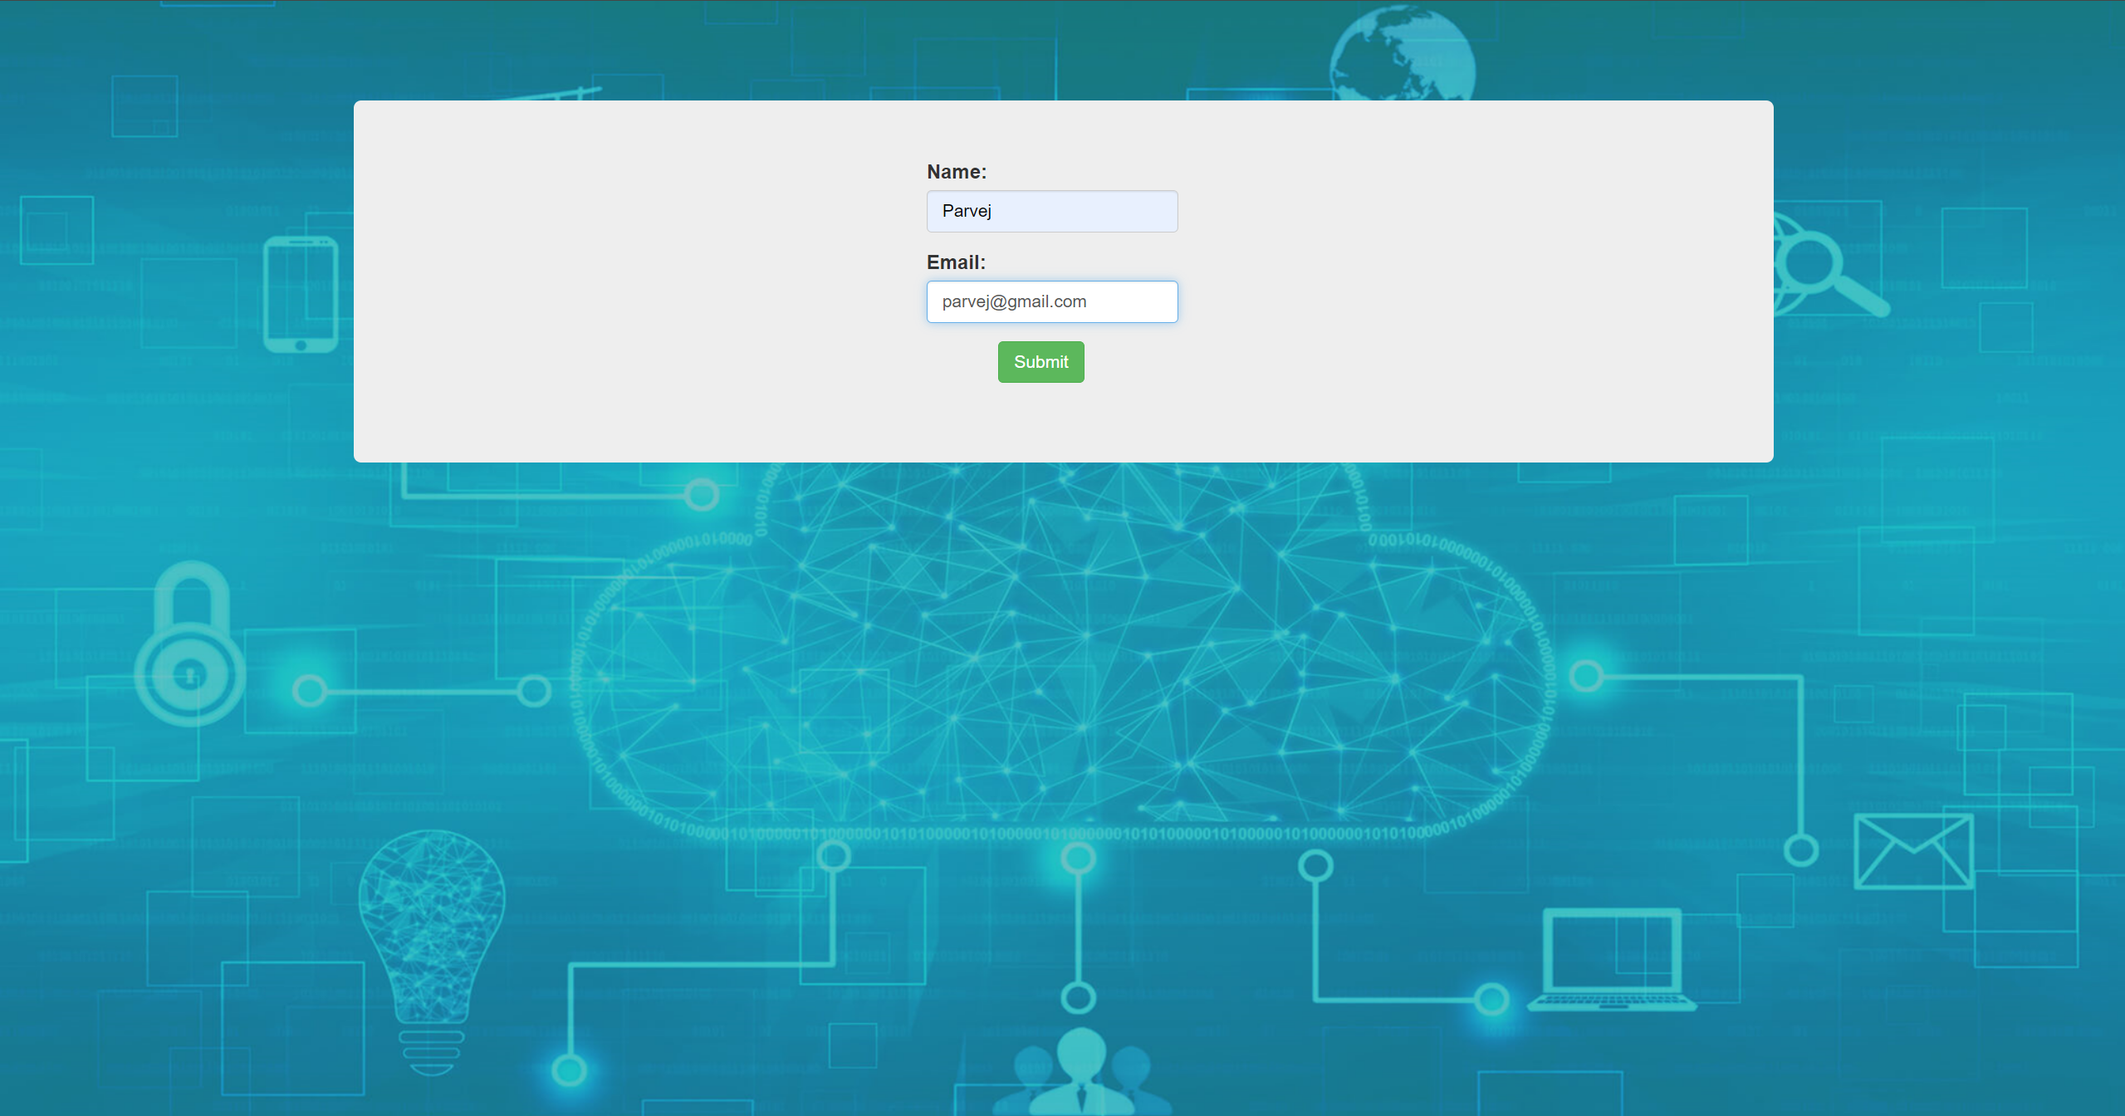  
Inserting some data in the blank fields.**

**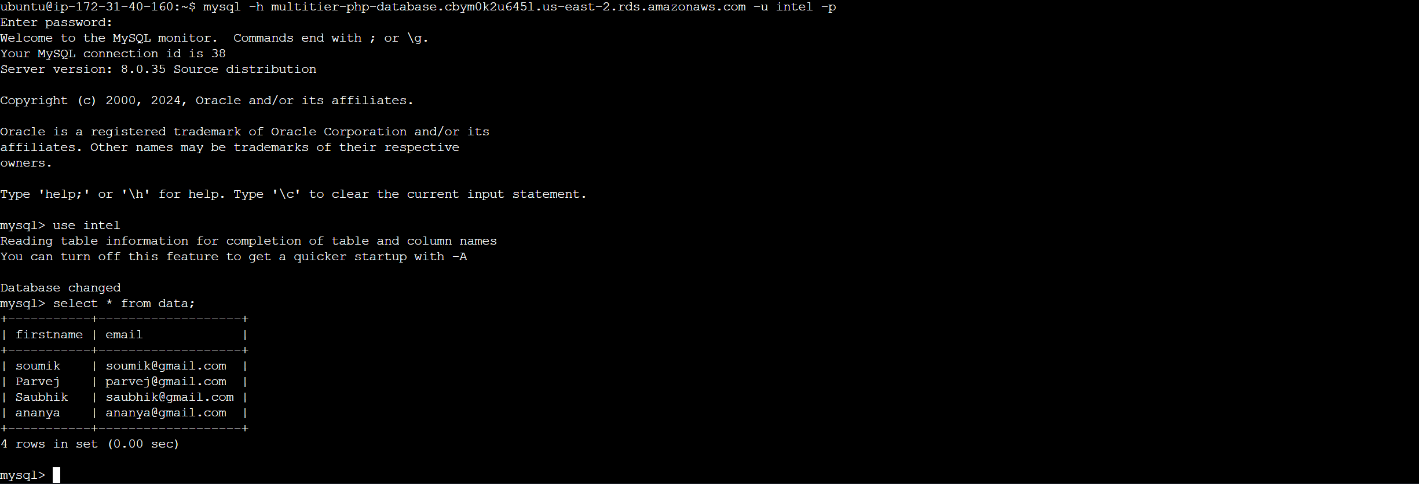  
Successfully fetched the data into the MySQL database from the PHP web server**

**Now we have to auto-scale the webserver for high availability-**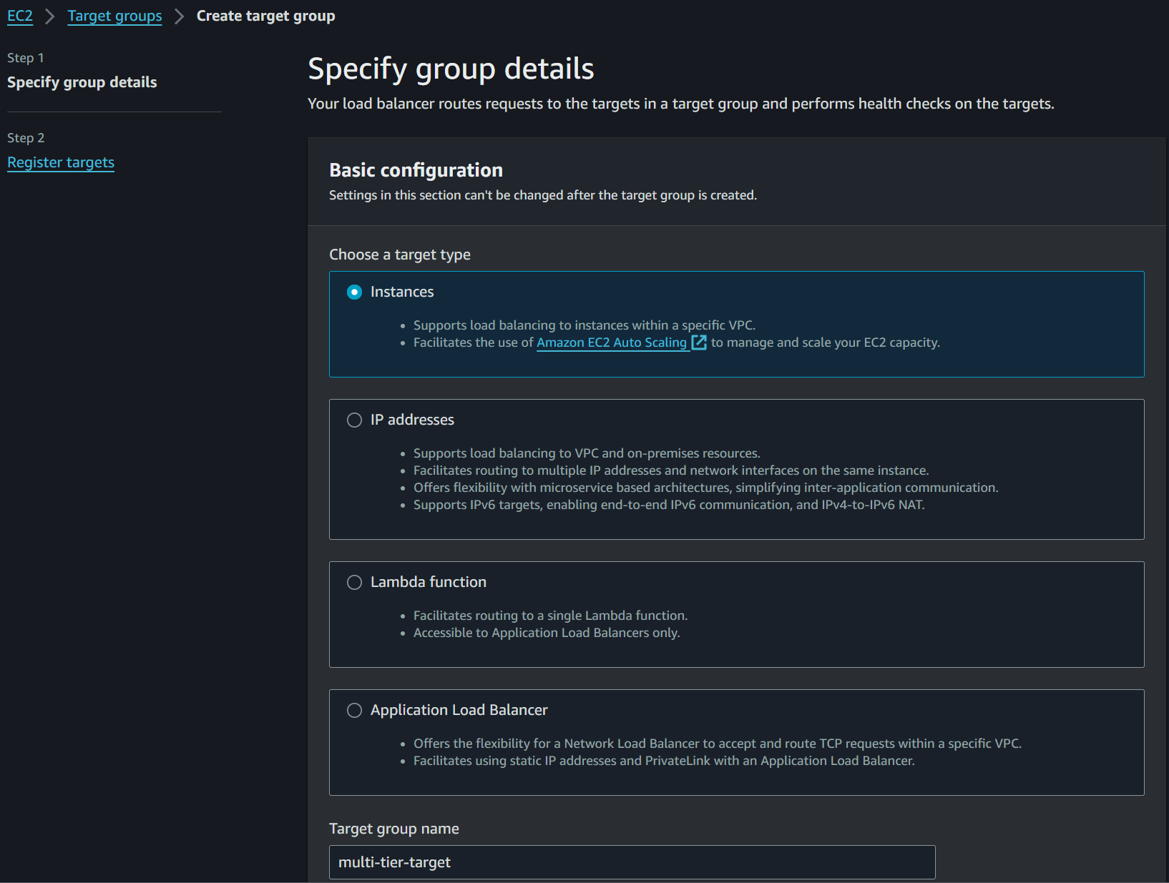 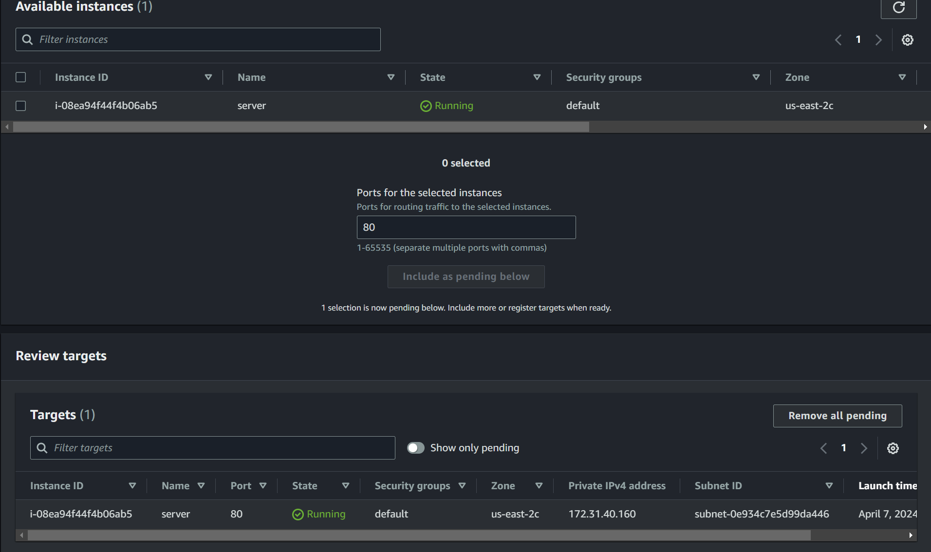

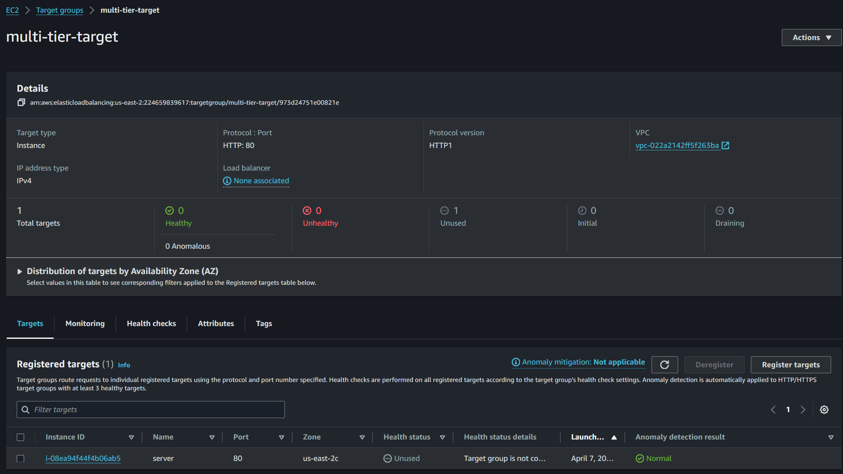 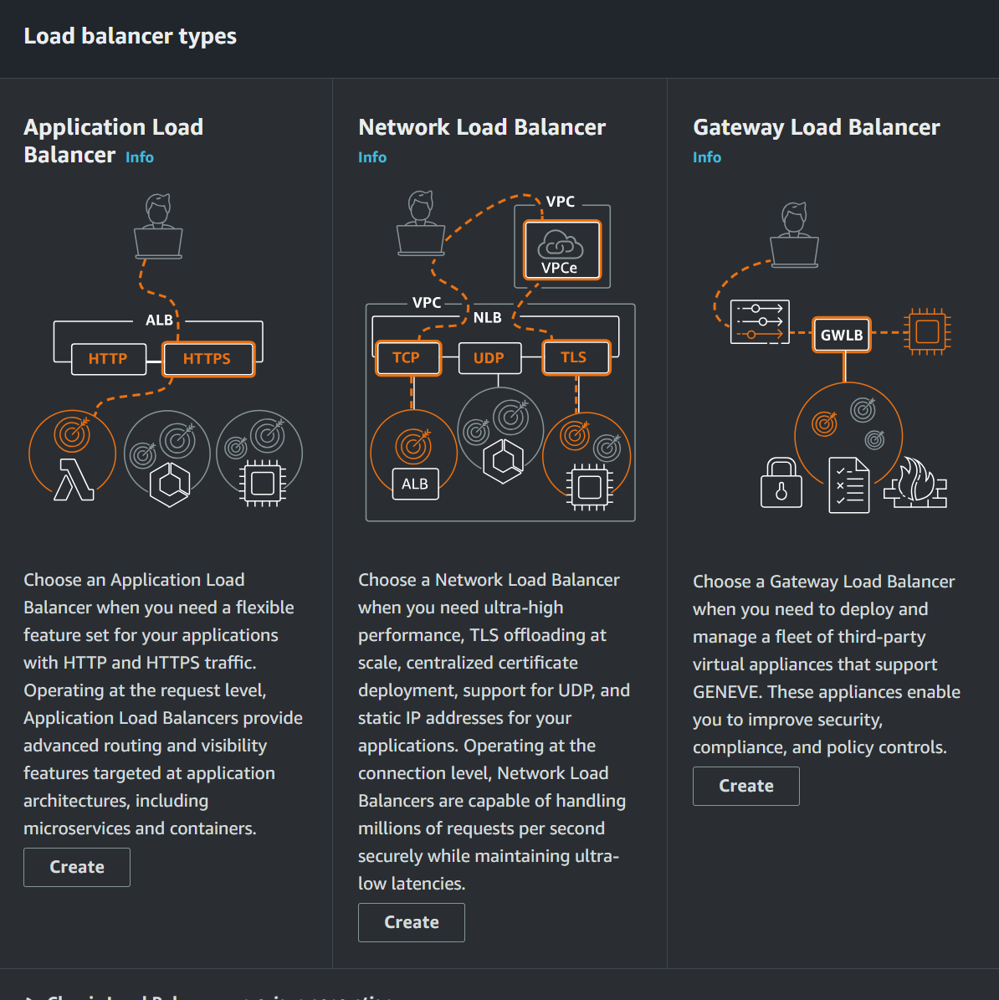

Load balancer creation

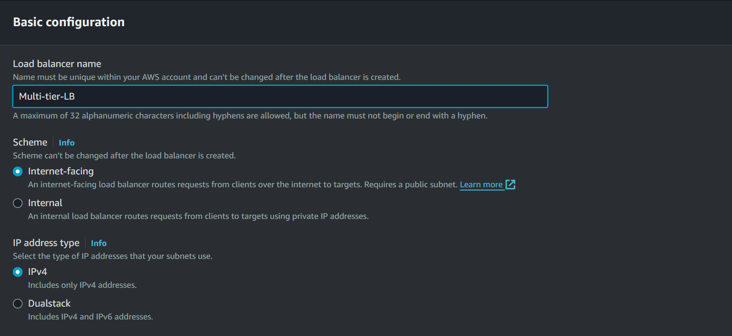 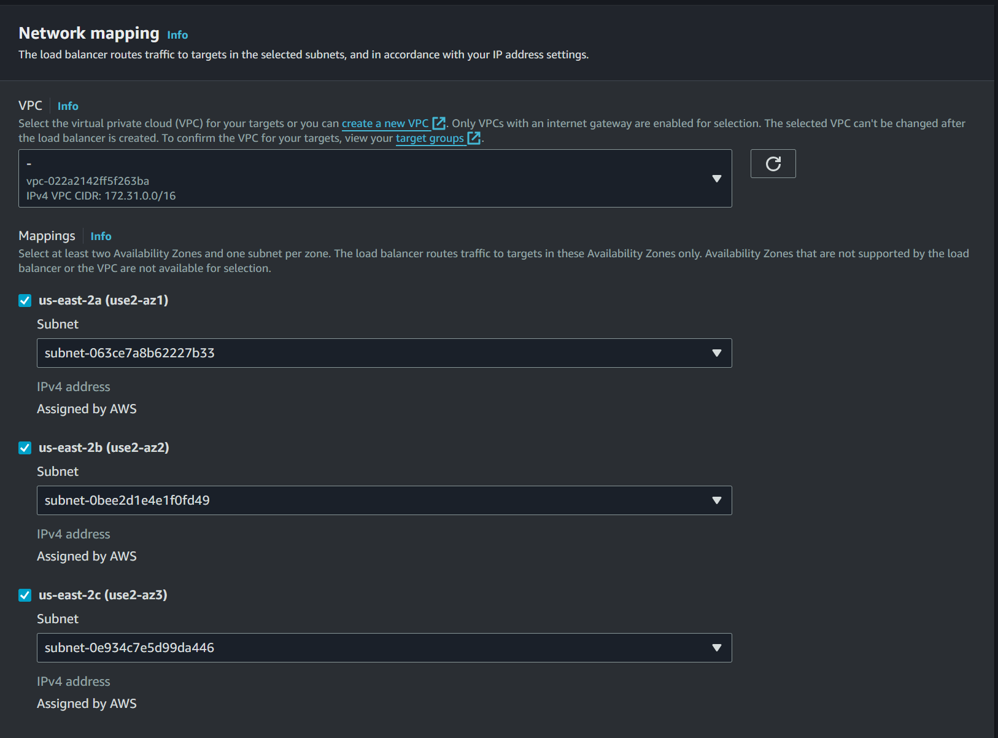

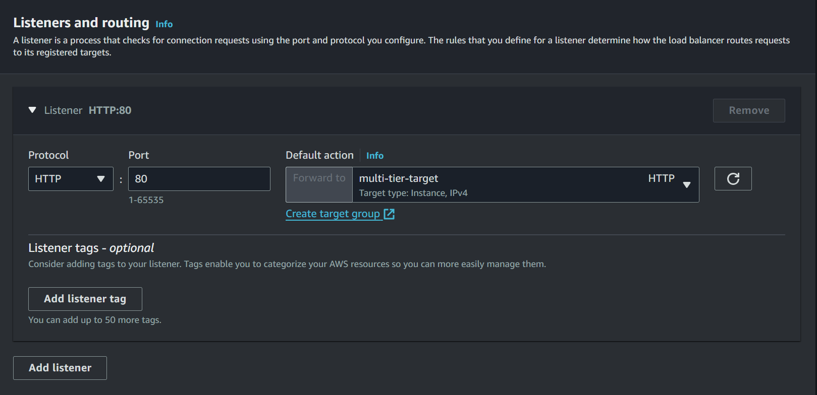 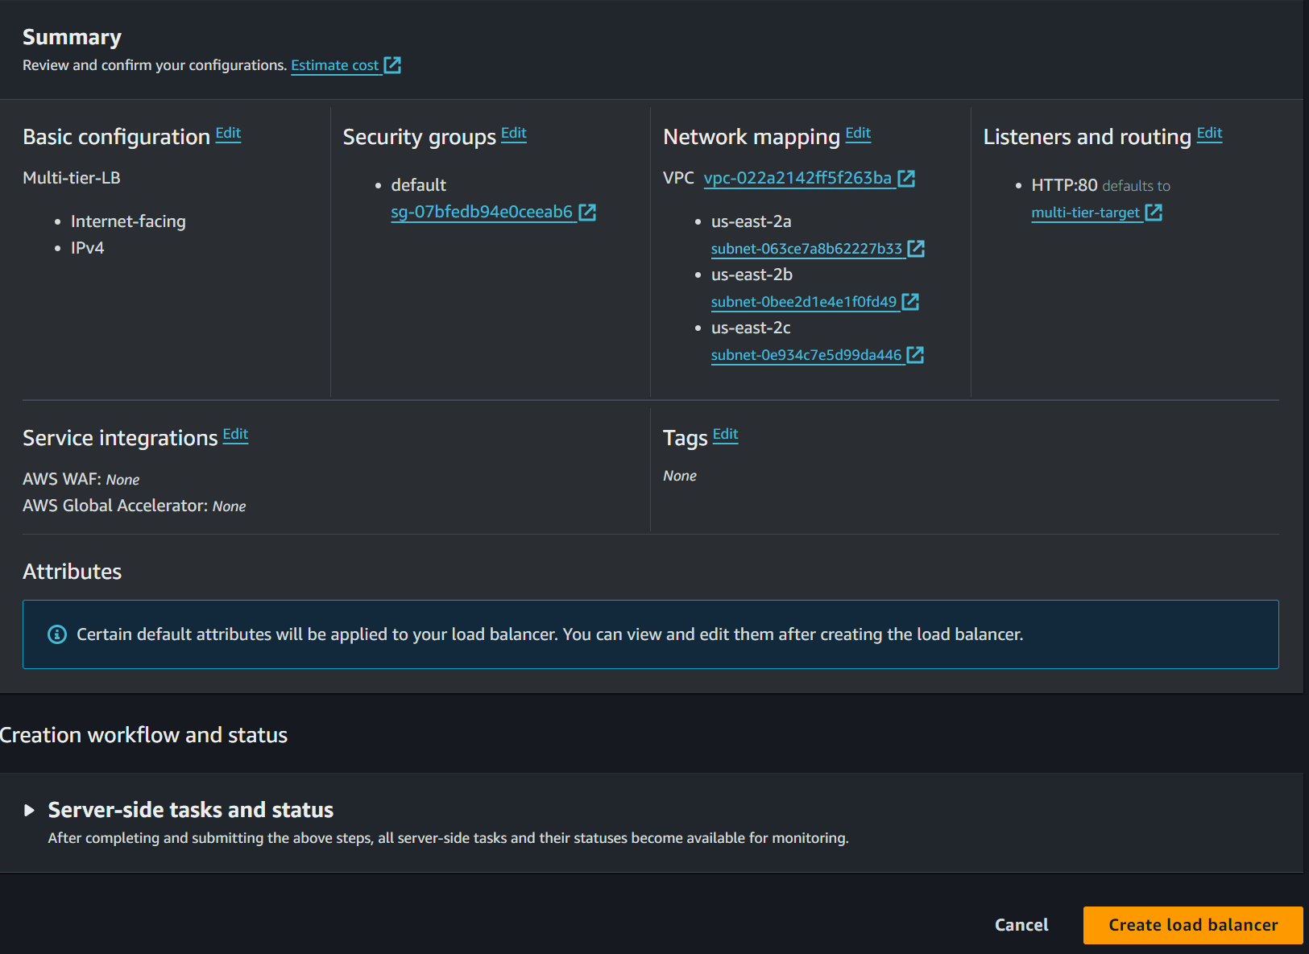

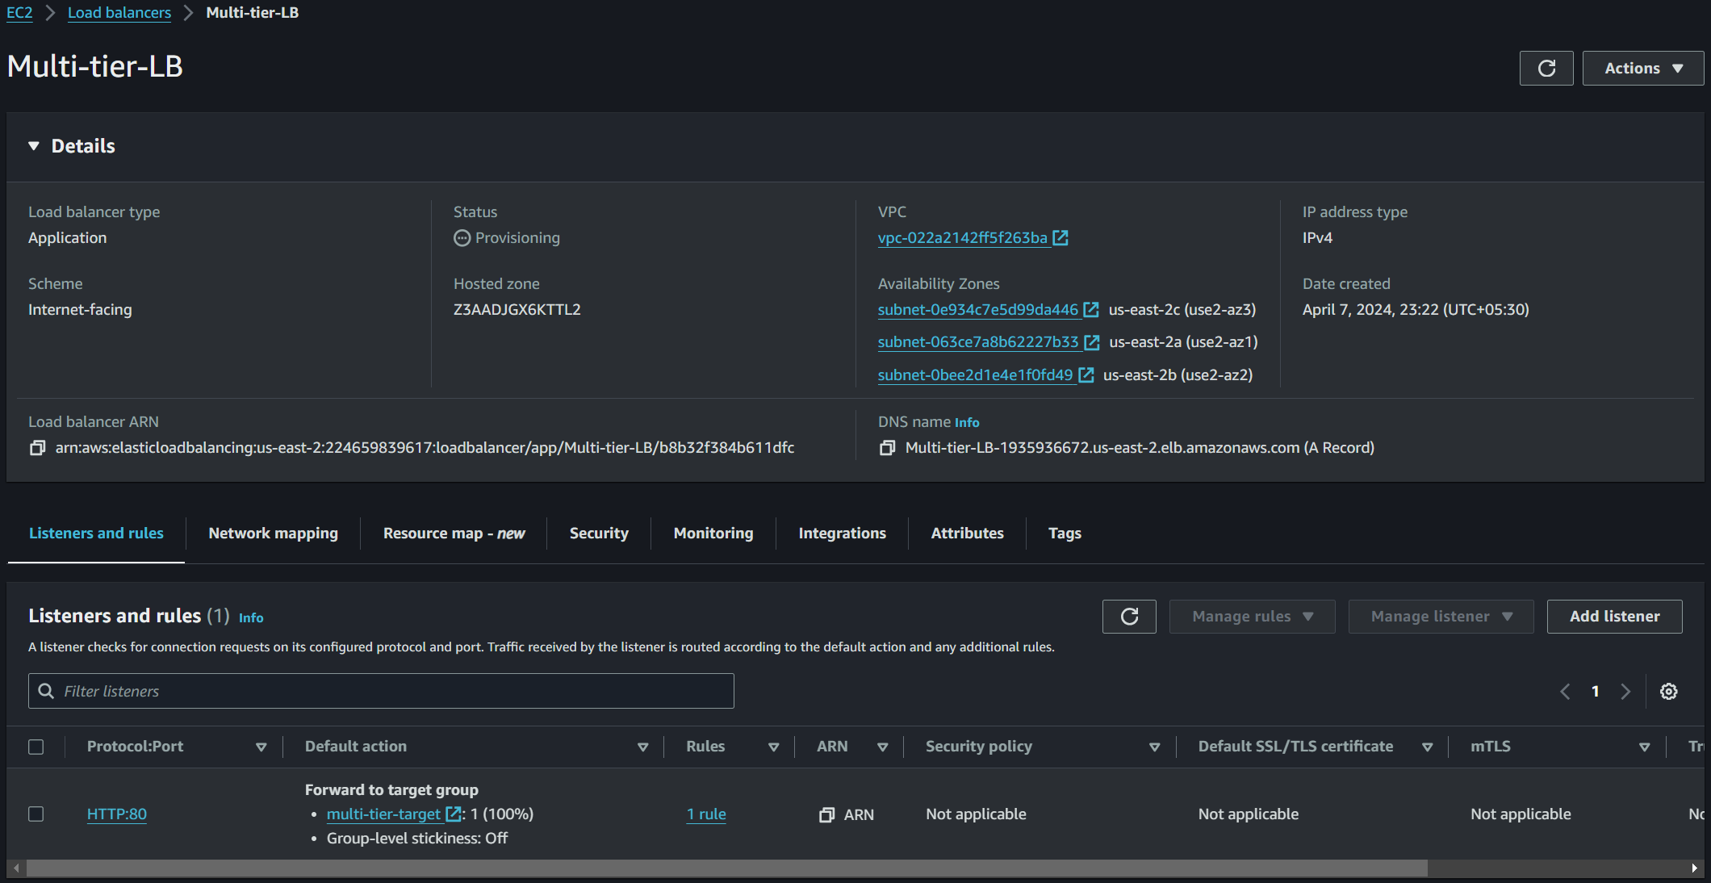  
**created load balancer**

**AMI (Amazon machine Image creation)**

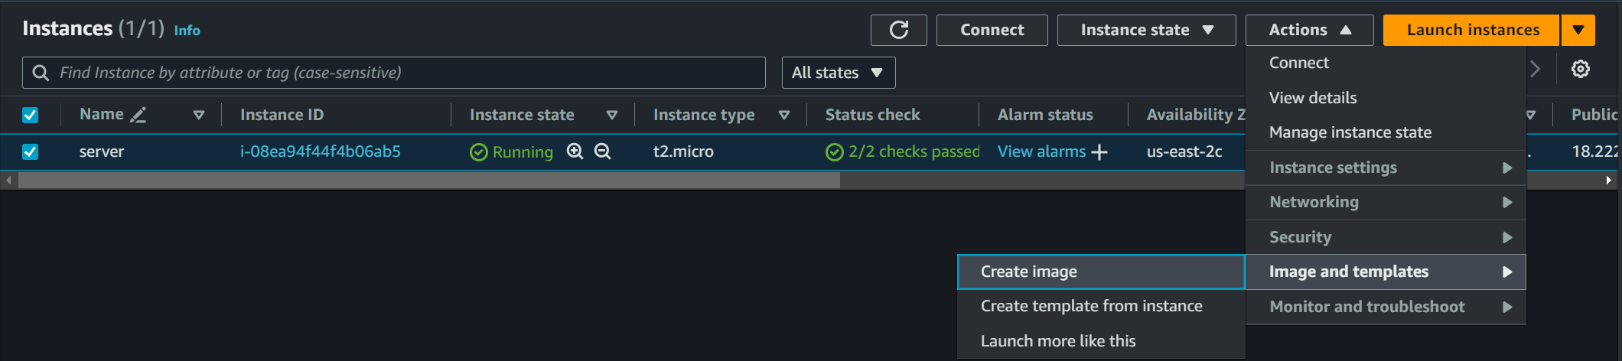

**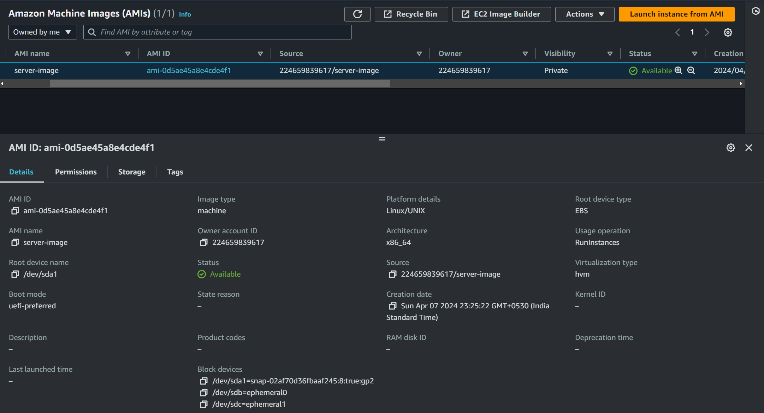  
Image created**

**Launch Template creation-**

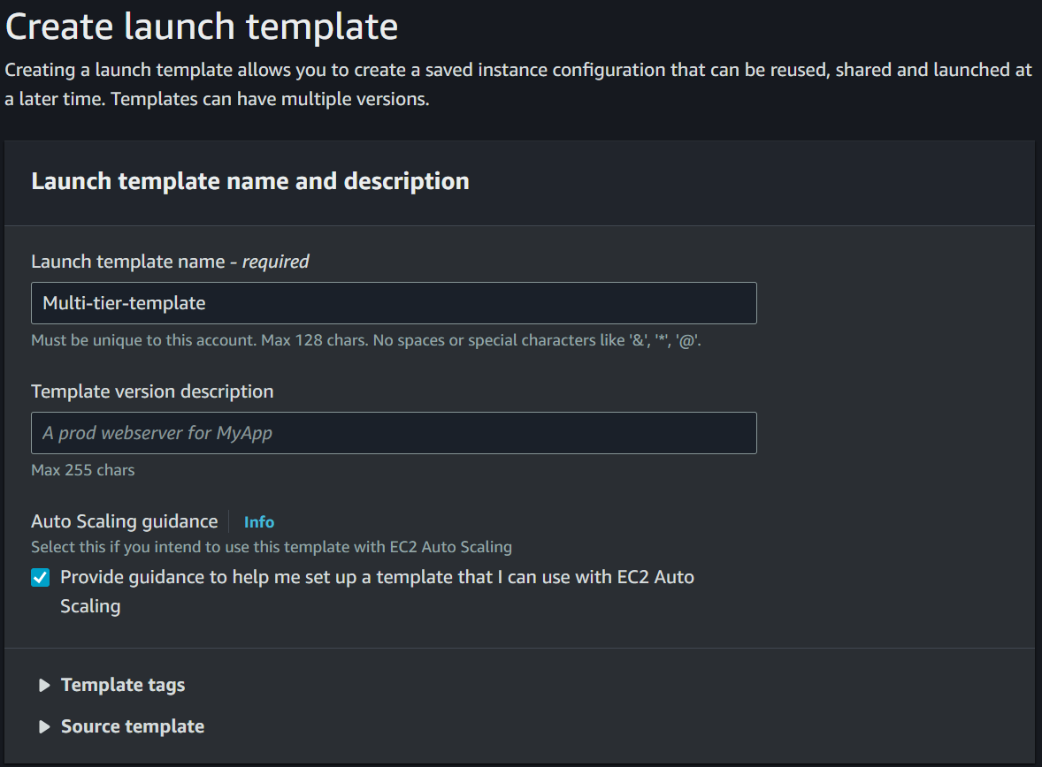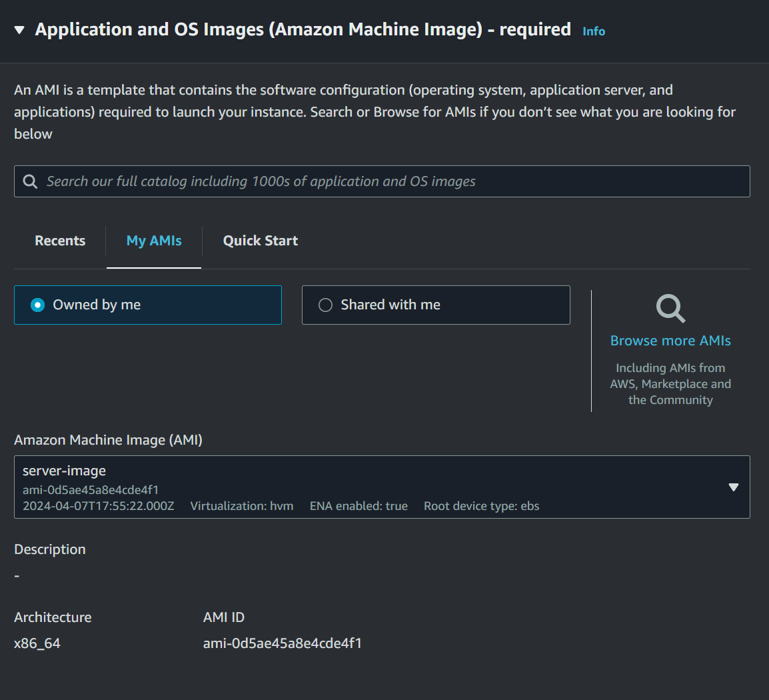

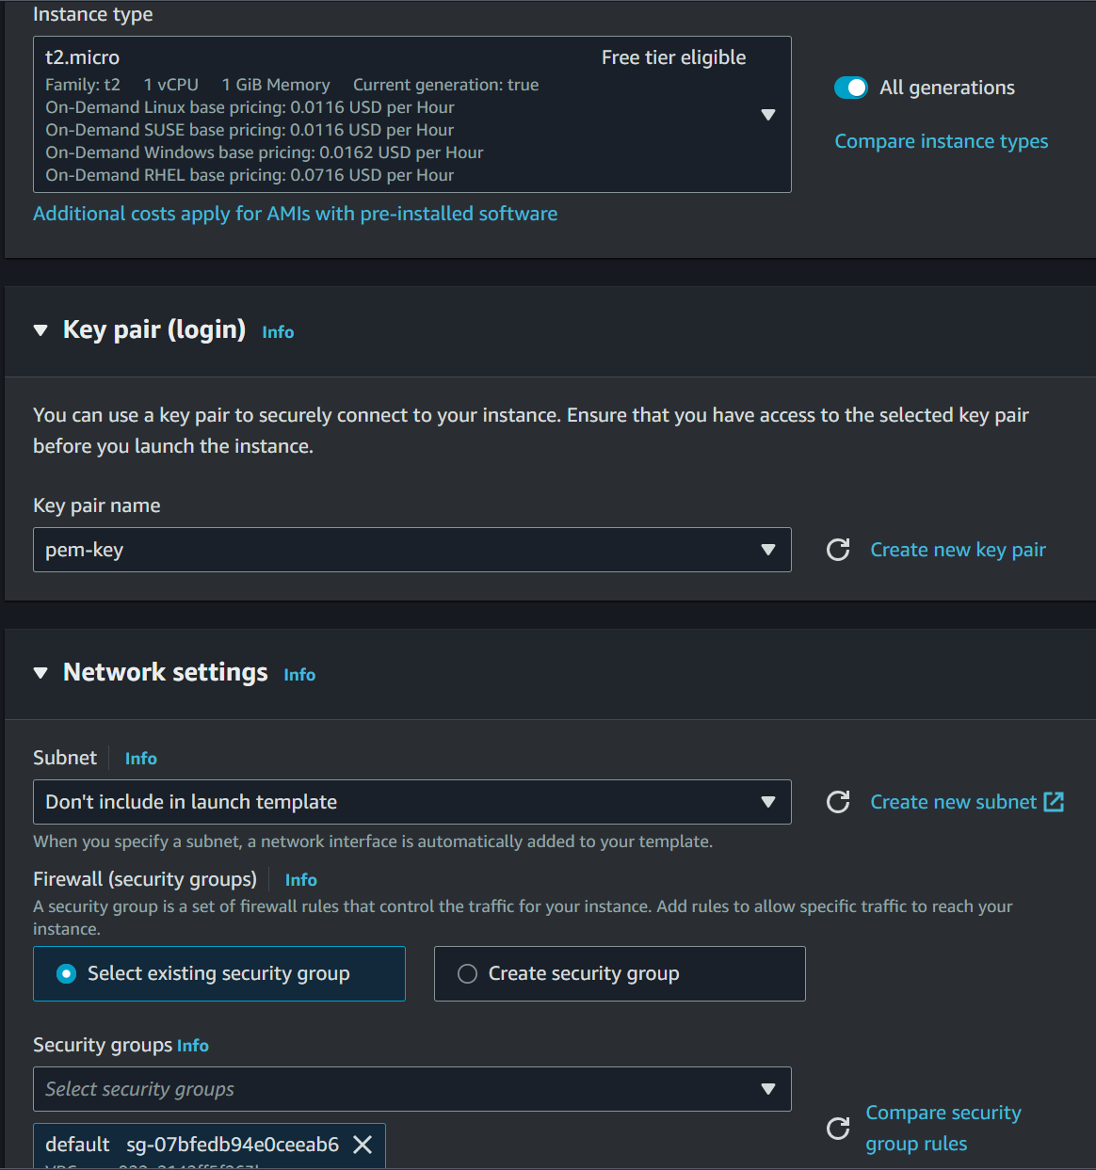 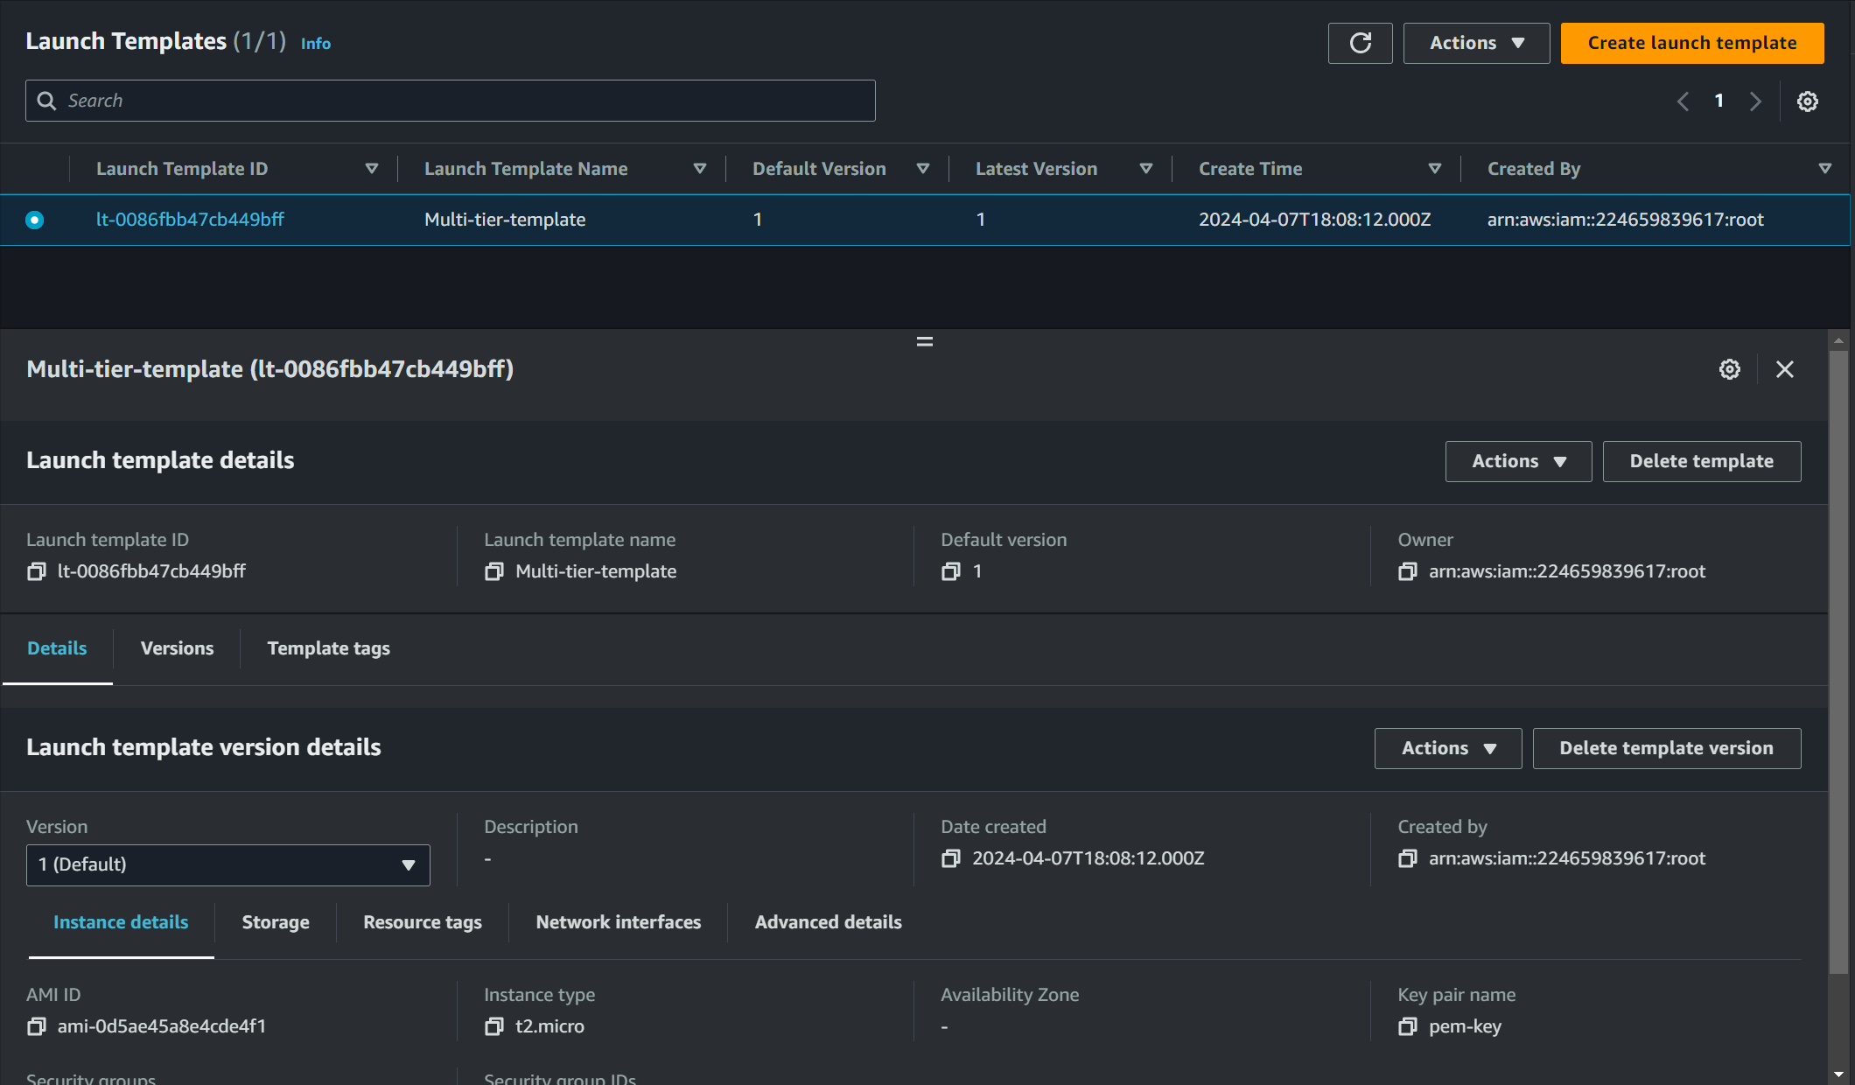  
**Created Launch Template**

**Creating Auto scaling group-**

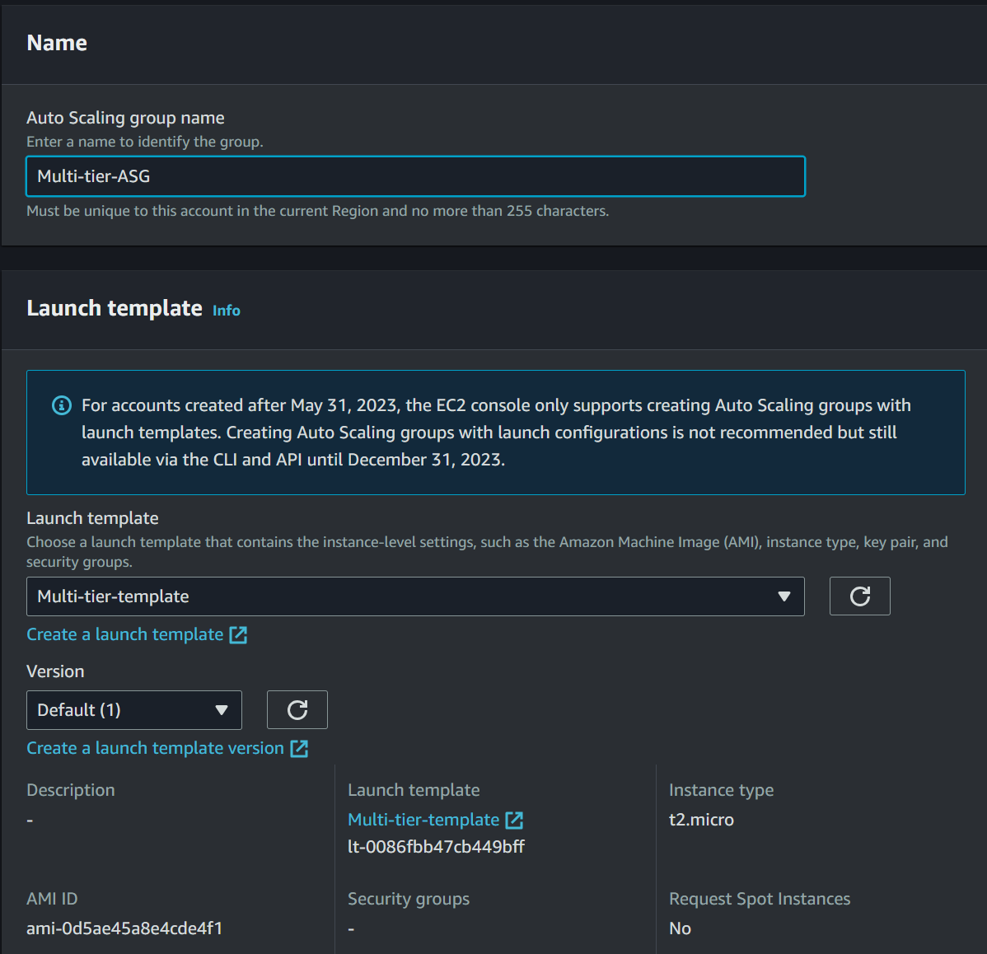 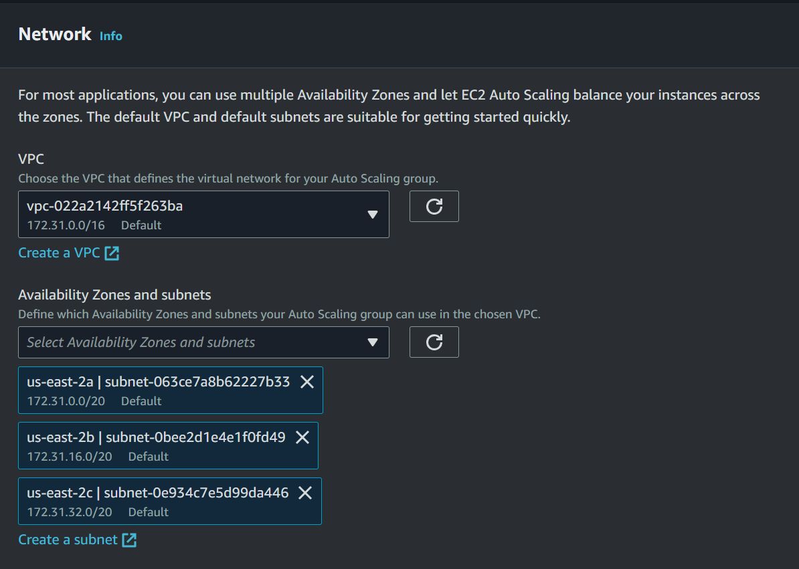

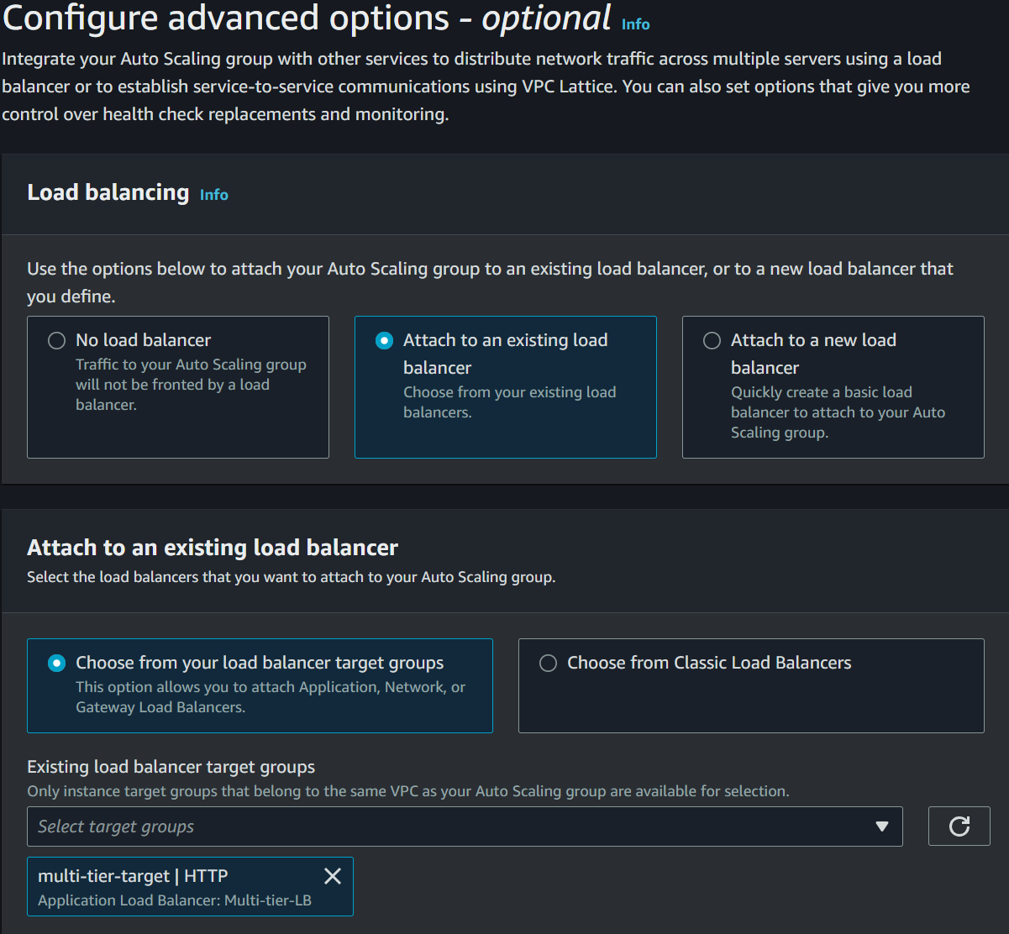 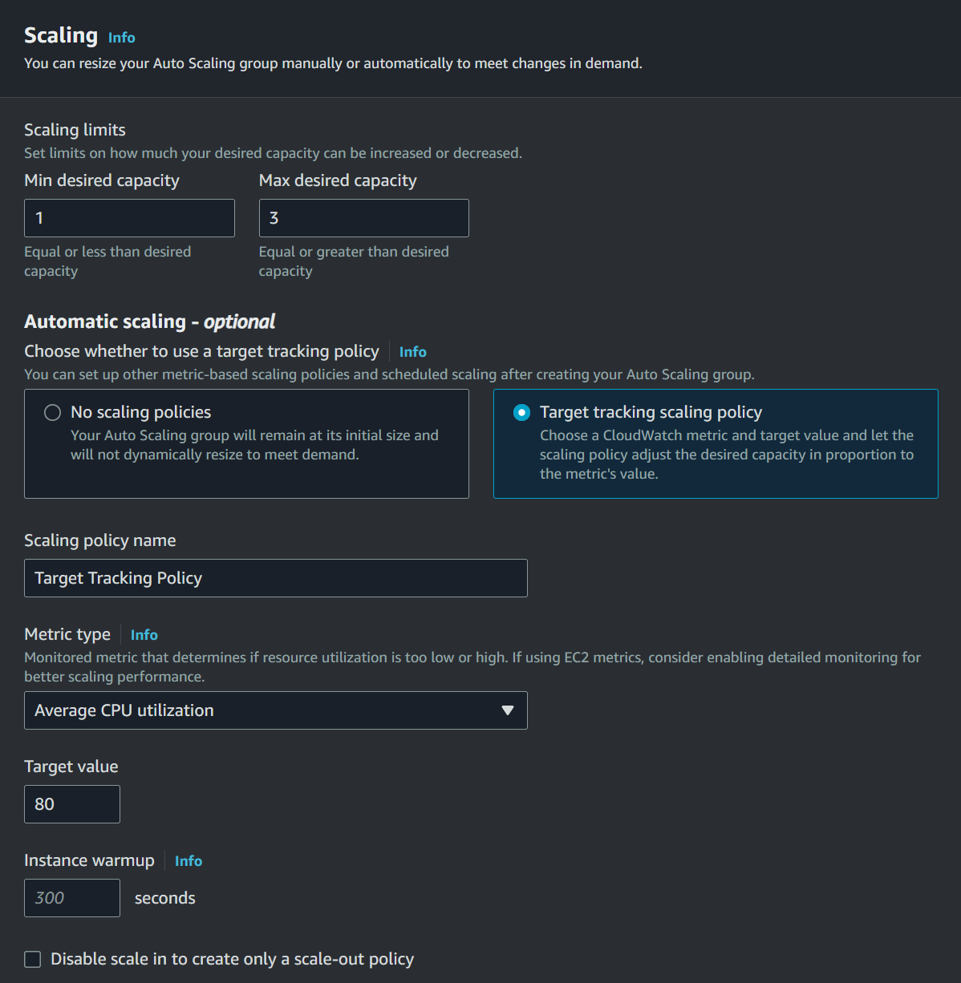

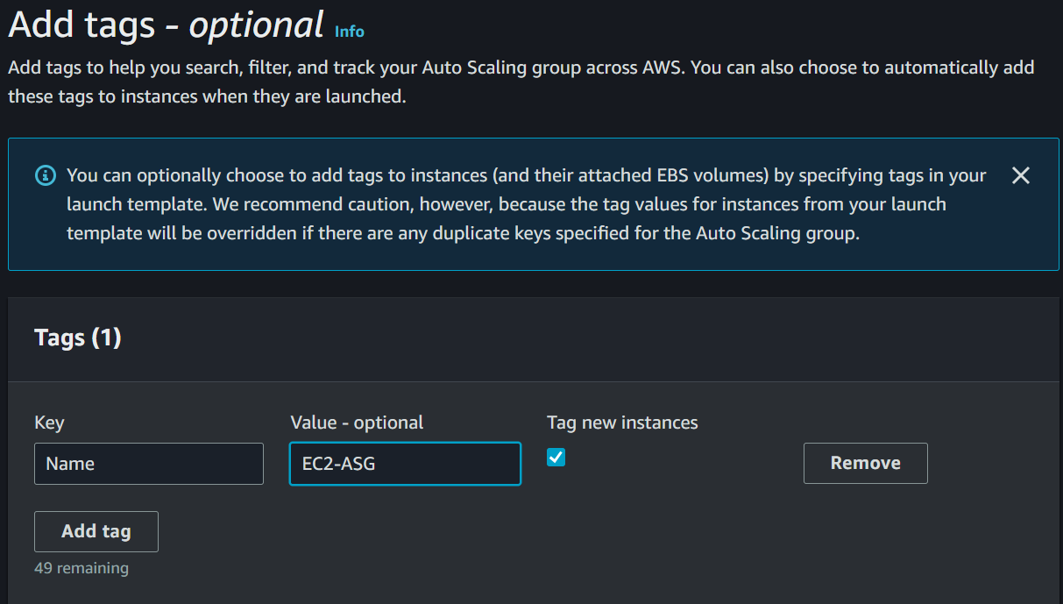**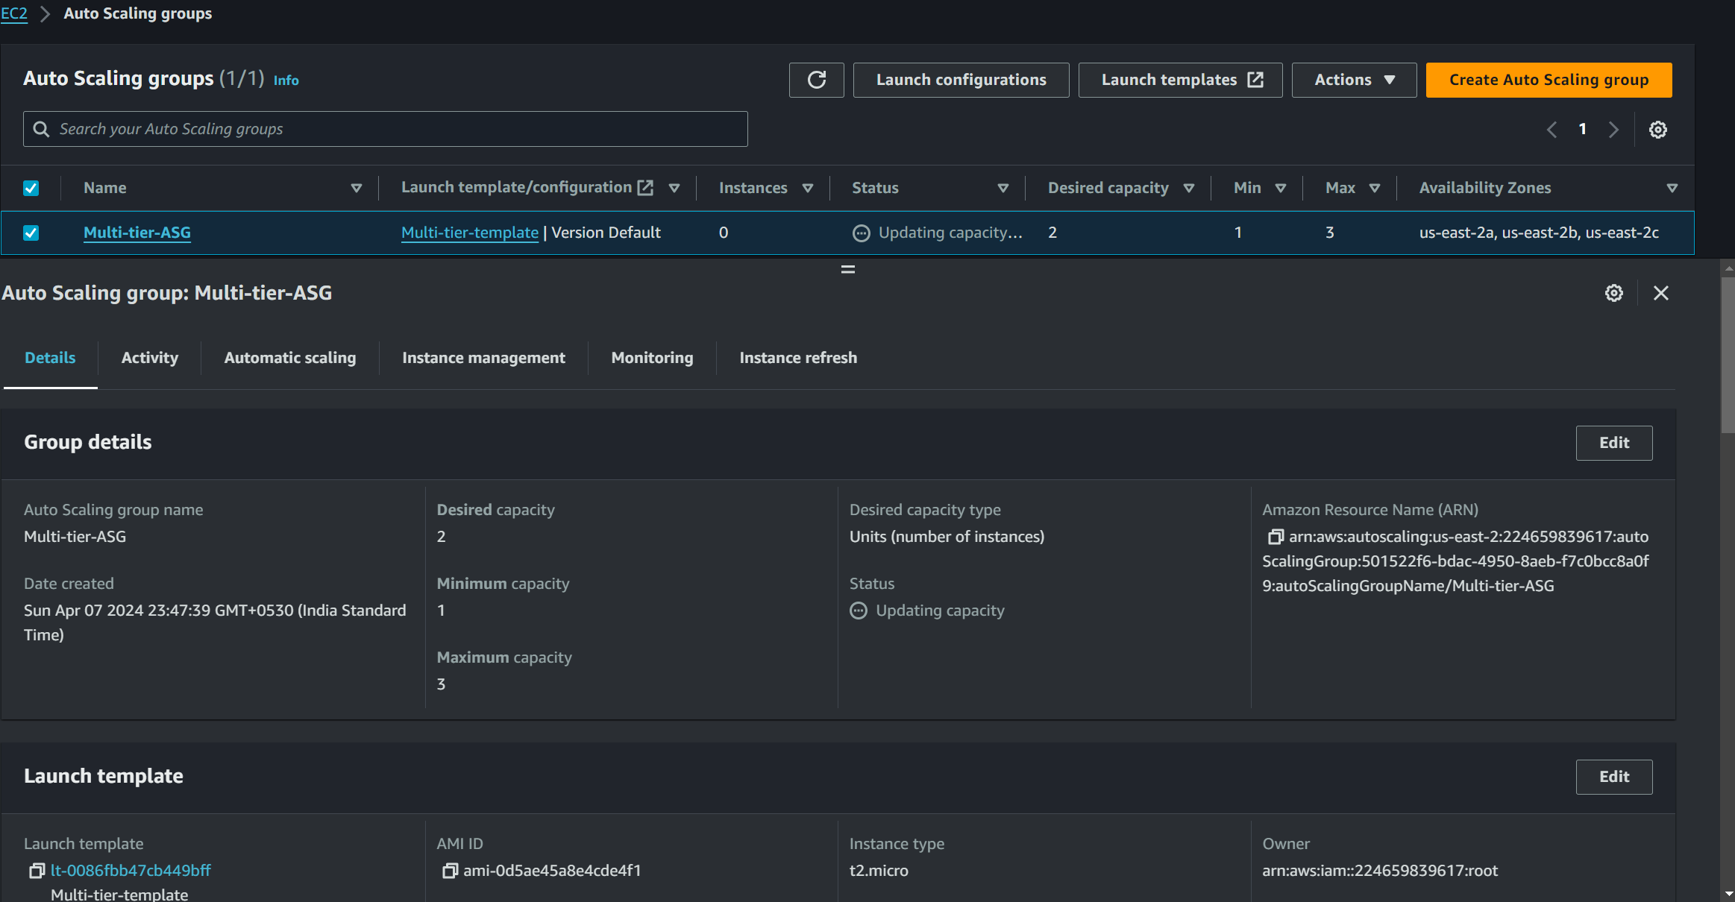  
Created Auto Scaling Group**

**Now check the instances**

**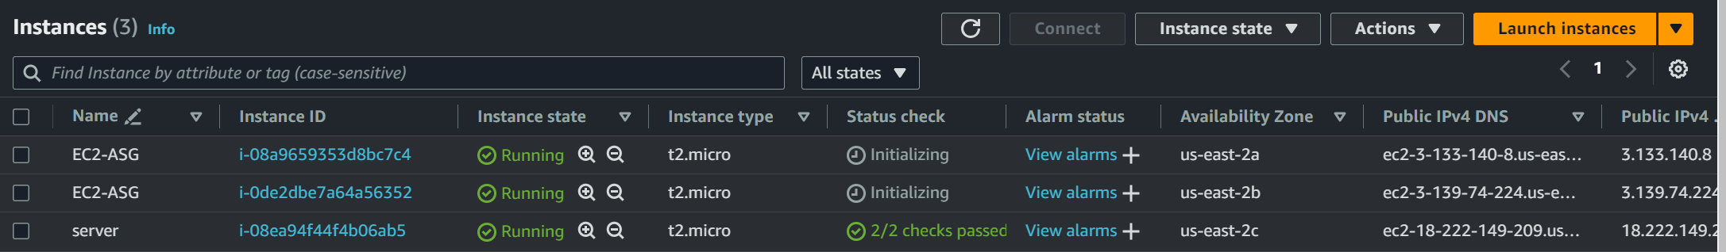  
Launched by ASG**

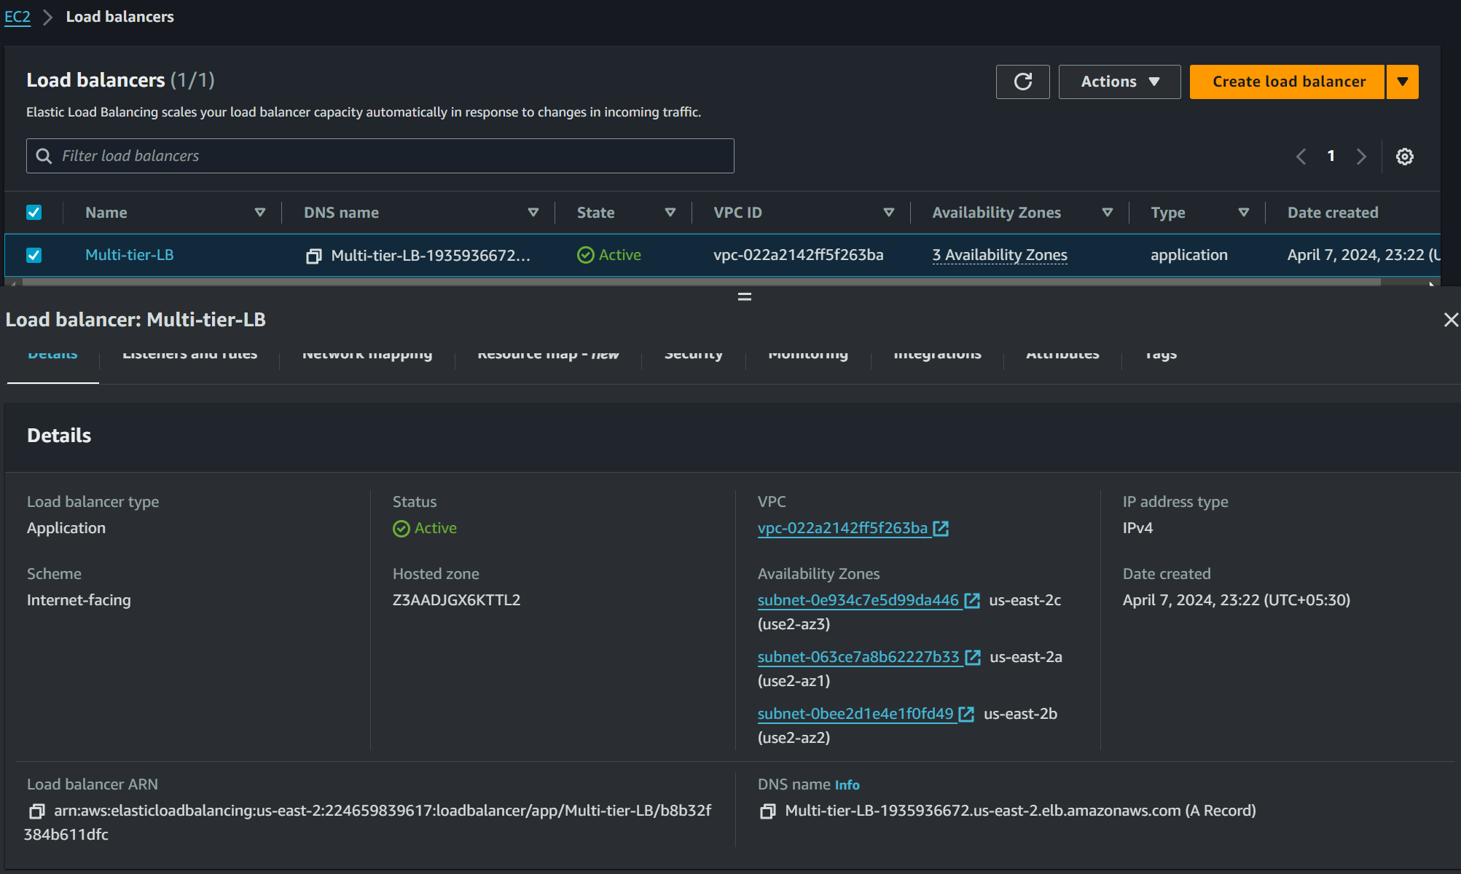**Copy the DNS name and paste this in browser and hit enter**

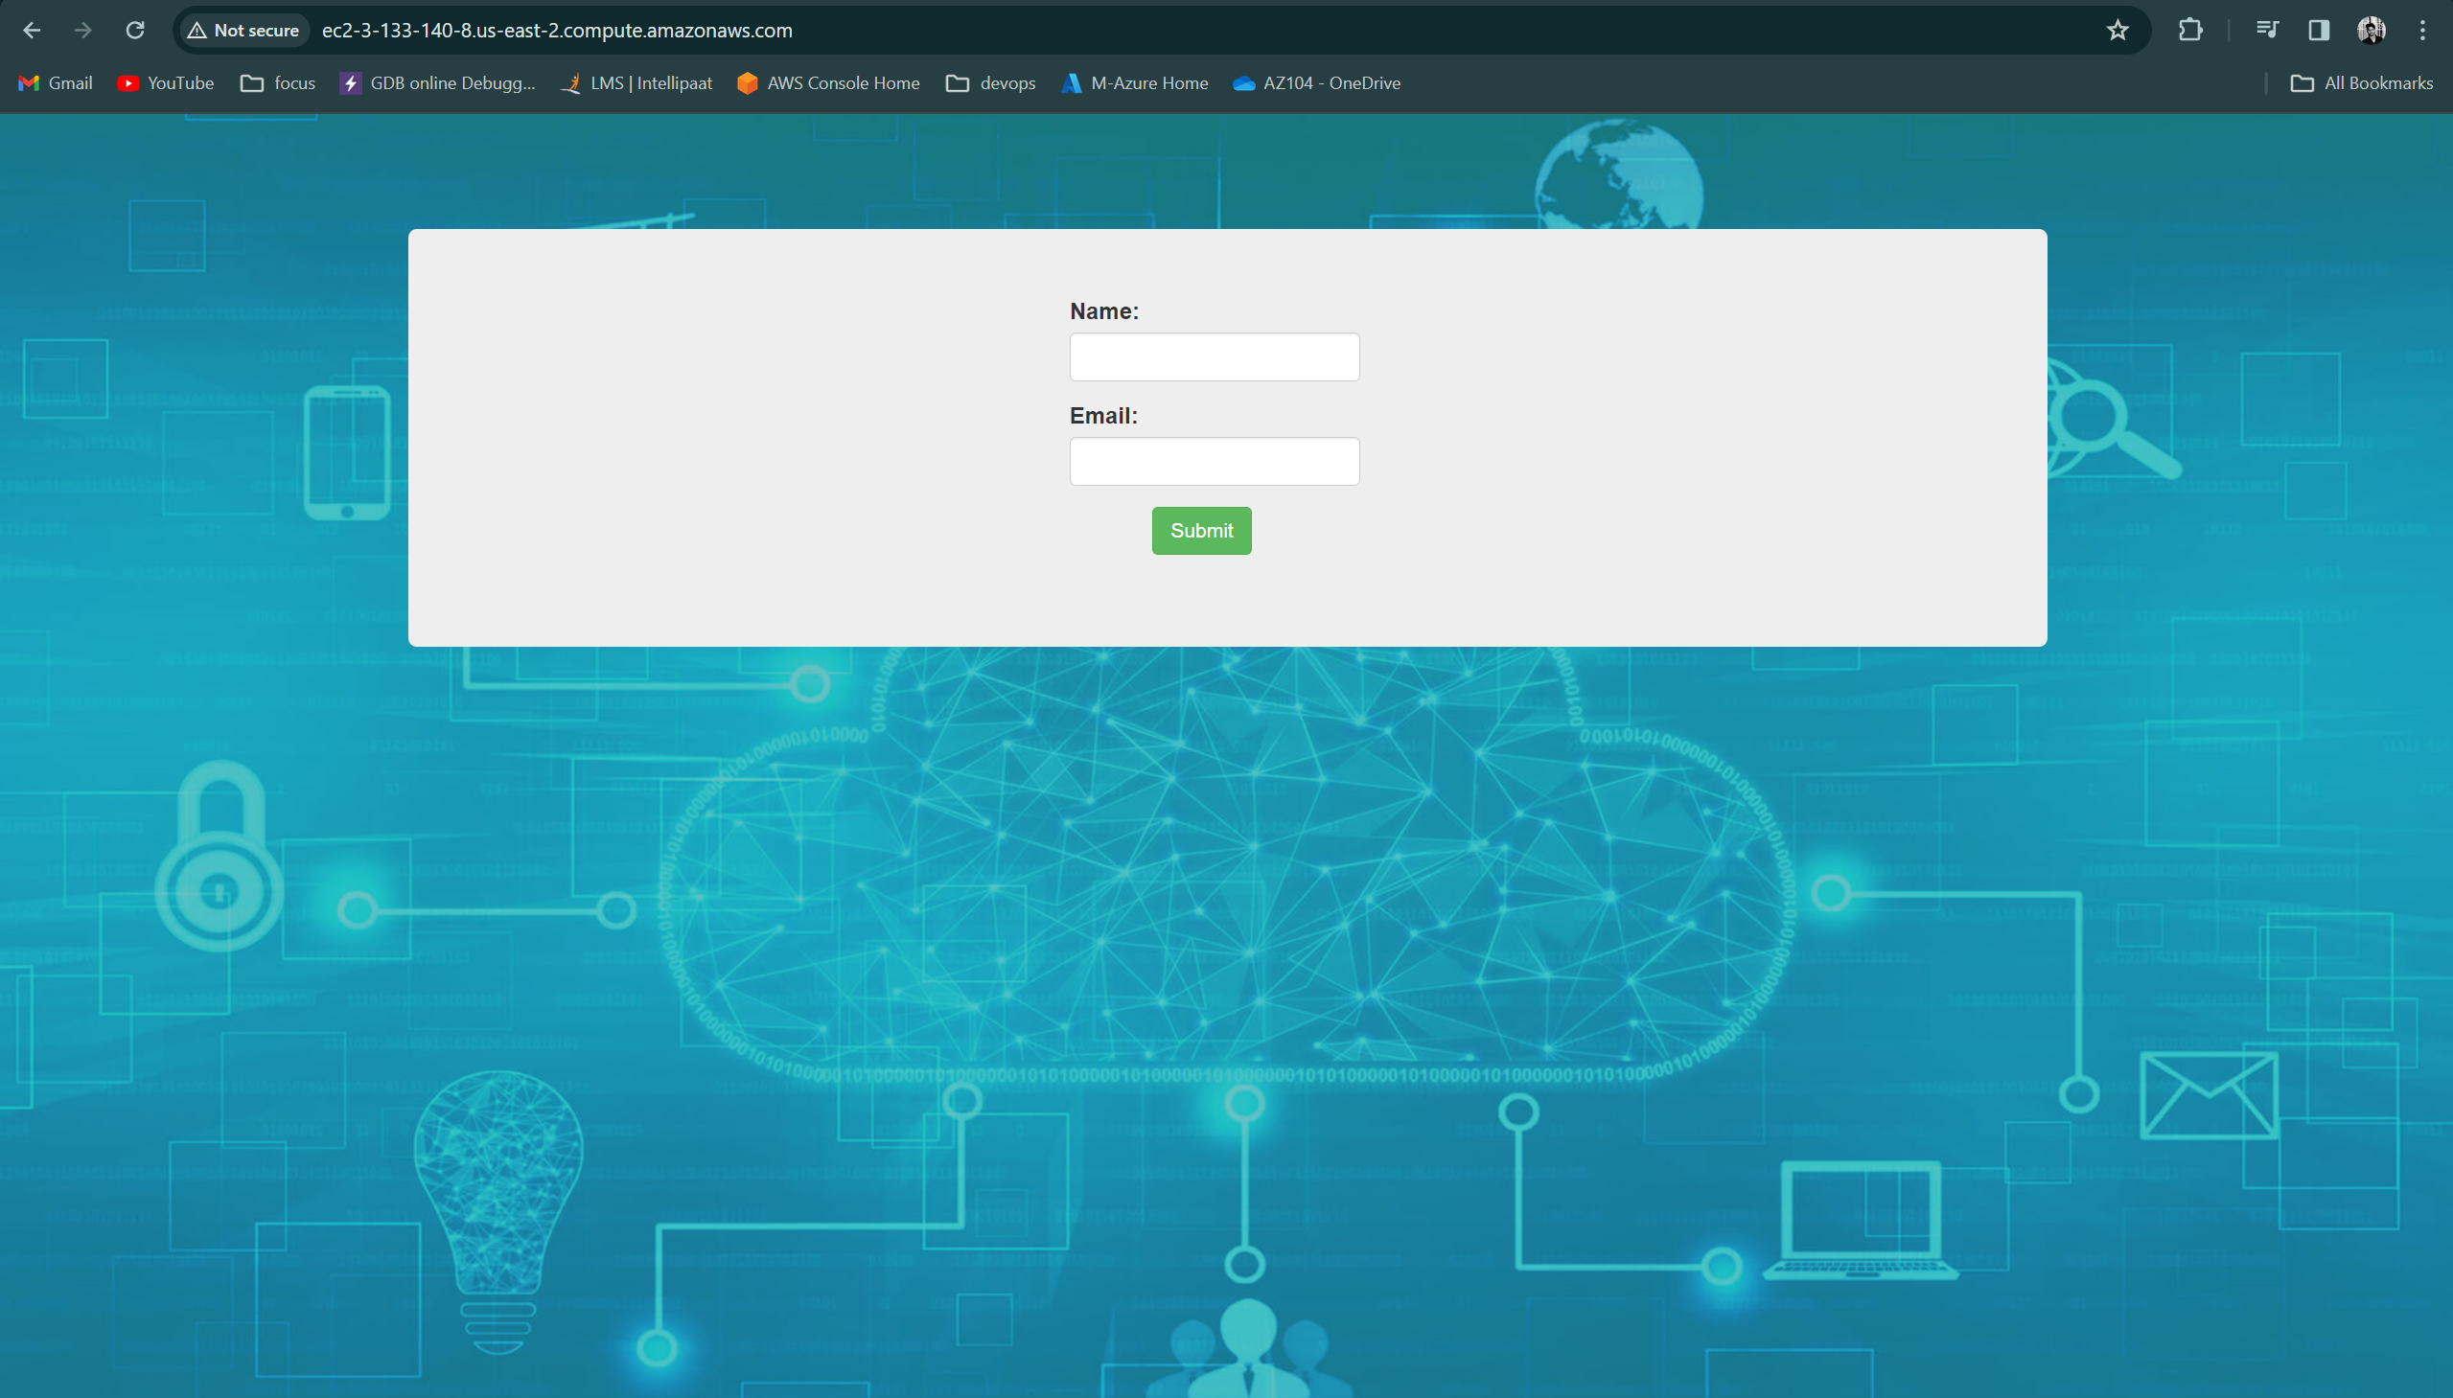

**Successfully implemented 2-tier architecture with High Availability PHP webserver and MySQL database**

**------------------------------------------------Thank You------------------------------------------------**